Marx and Engels on the Misconceptions of Communism
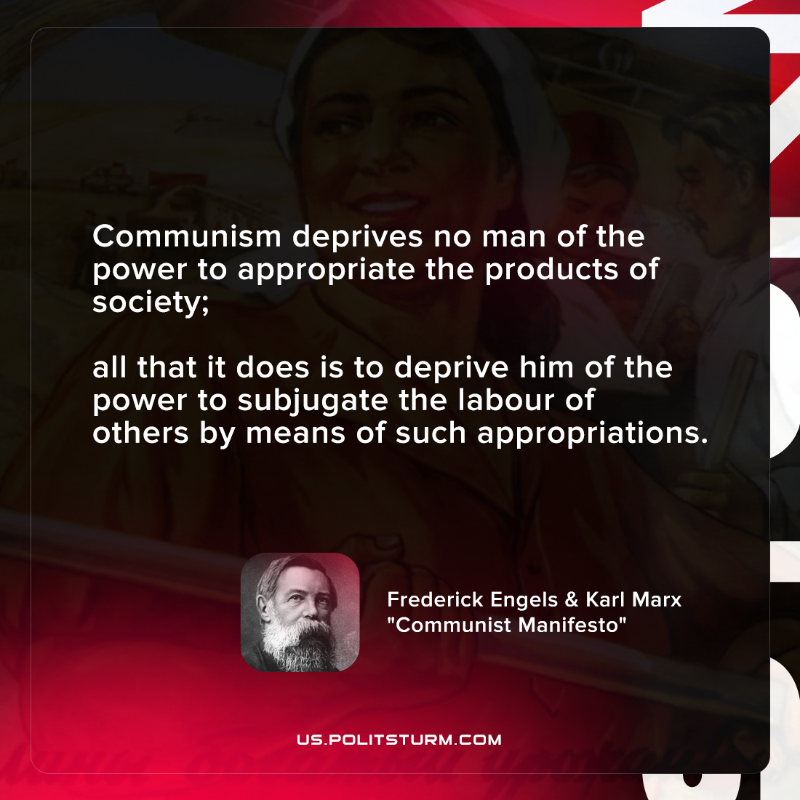

Original article
2021-12-10

Communism deprives no man of the power to appropriate the products of society; all that it does is to deprive him of the power to subjugate the labour of others by means of such appropriations.

Karl Marx and Frederick Engels, “Manifesto of the Communist Party”

Original article

