Marx and Engels on the Material Reproduction of Man
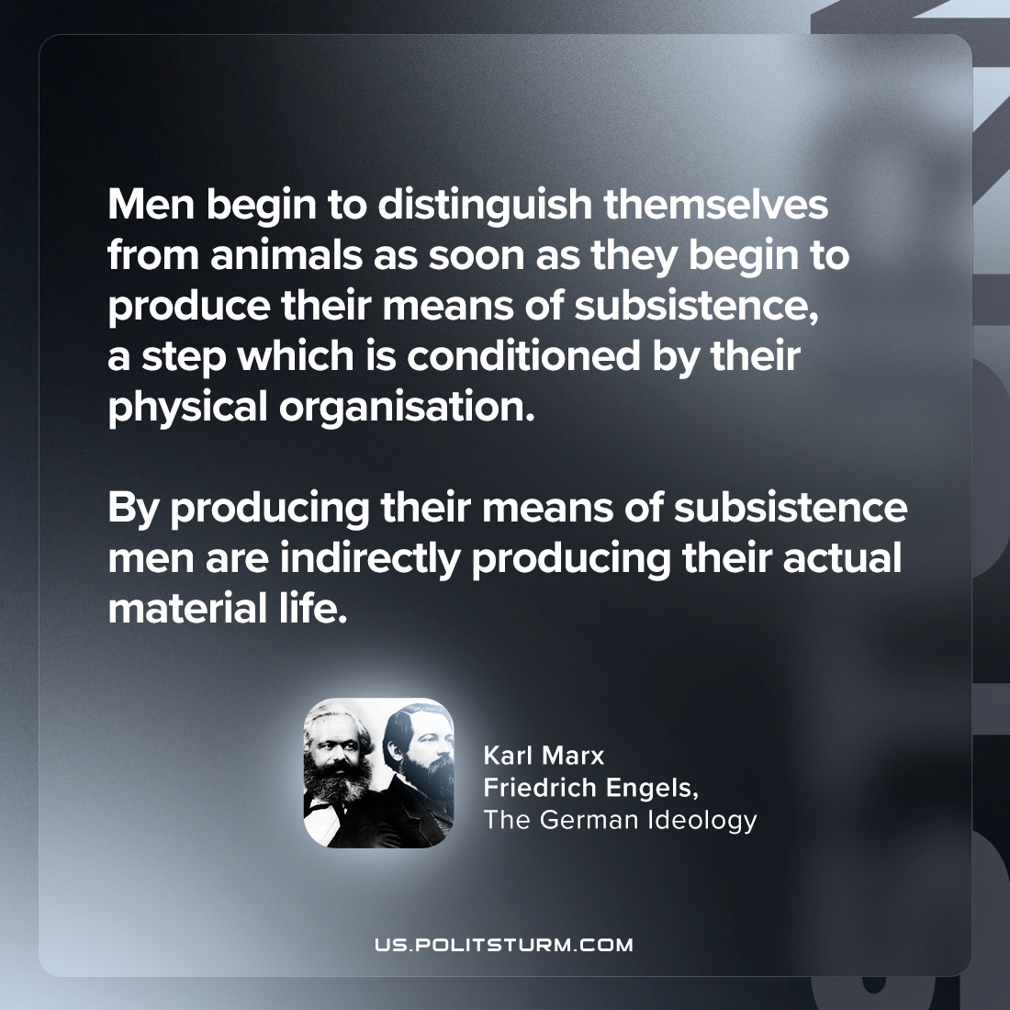

Original article
2024-05-12

"Men begin to distinguish themselves from animals as soon as they begin to produce their means of subsistence, a step which is conditioned by their physical organisation. By producing their means of subsistence men are indirectly producing their actual material life."
Karl Marx and Friedrich Engels, The German Ideology

Original article

