Marx and Engels on the Material Influence of Ideas
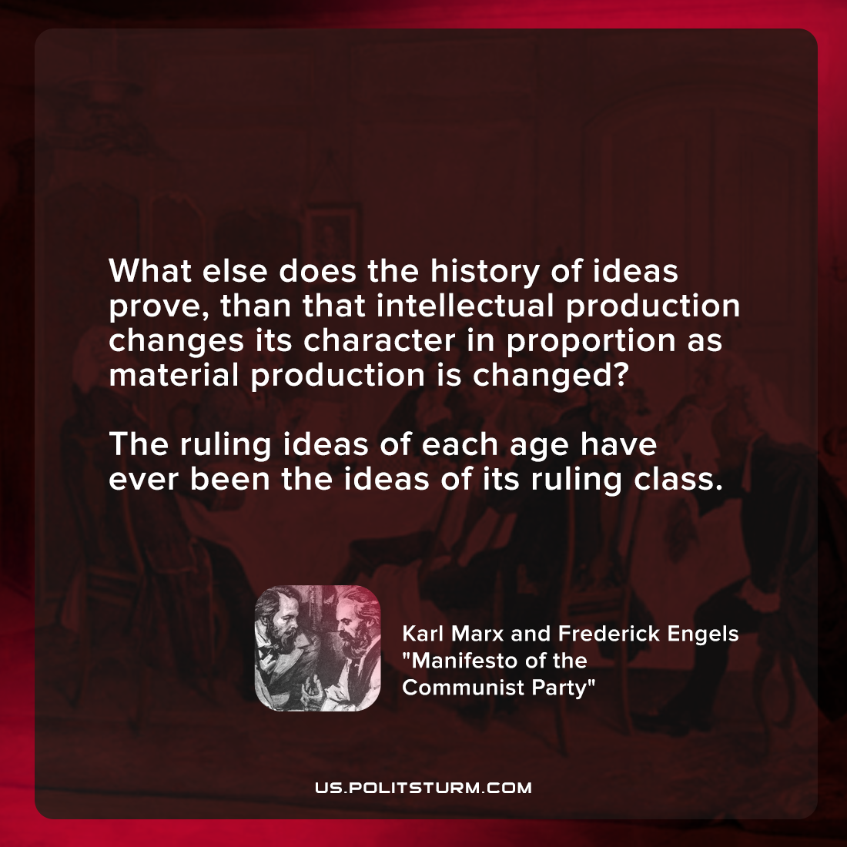

Original article
2022-02-19

What else does the history of ideas prove, than that intellectual production changes its character in proportion as material production is changed? The ruling ideas of each age have ever been the ideas of its ruling class.

Karl Marx and Frederick Engels, “Manifesto of the Communist Party”

Original article

