Marx and Engels on the Communist Party
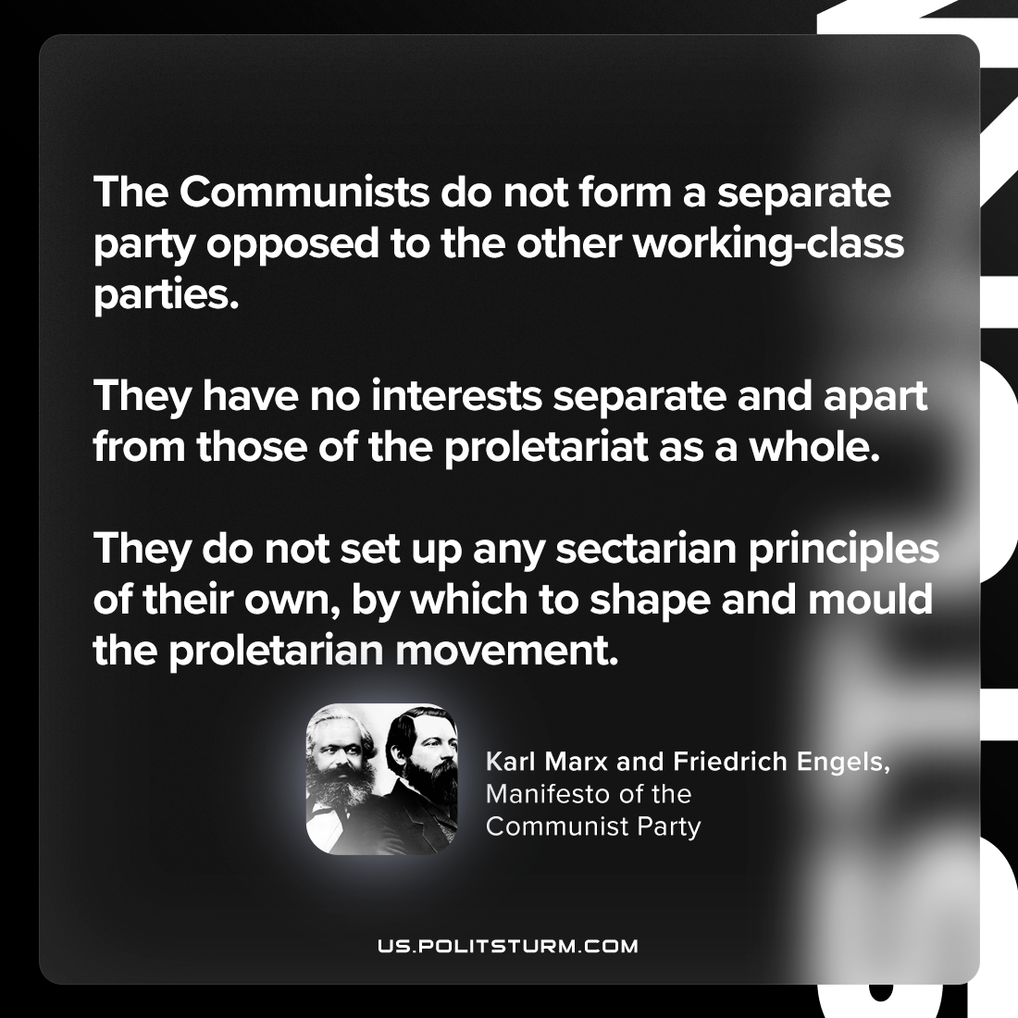

Original article
2024-02-22

"The Communists do not form a separate party opposed to the other working-class parties. They have no interests separate and apart from those of the proletariat as a whole. They do not set up any sectarian principles of their own, by which to shape and mould the proletarian movement."
Karl Marx and Friedrich Engels, The Manifesto of the Communist Party

Original article

