Marx and Engels on the Abolition of Private Property
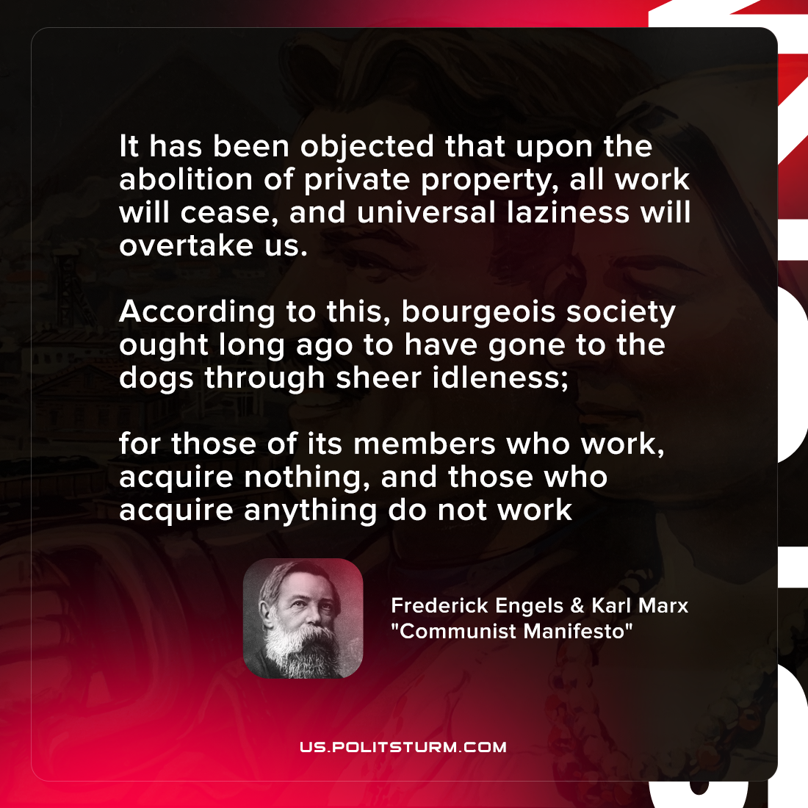

Original article
2021-12-16

It has been objected that upon the abolition of private property, all work will cease, and universal laziness will overtake us.
According to this, bourgeois society ought long ago to have gone to the dogs through sheer idleness; for those of its members who work, acquire nothing, and those who acquire anything do not work

Karl Marx and Frederick Engels, “Manifesto of the Communist Party”

Original article

