Marx and Engels on Ideology
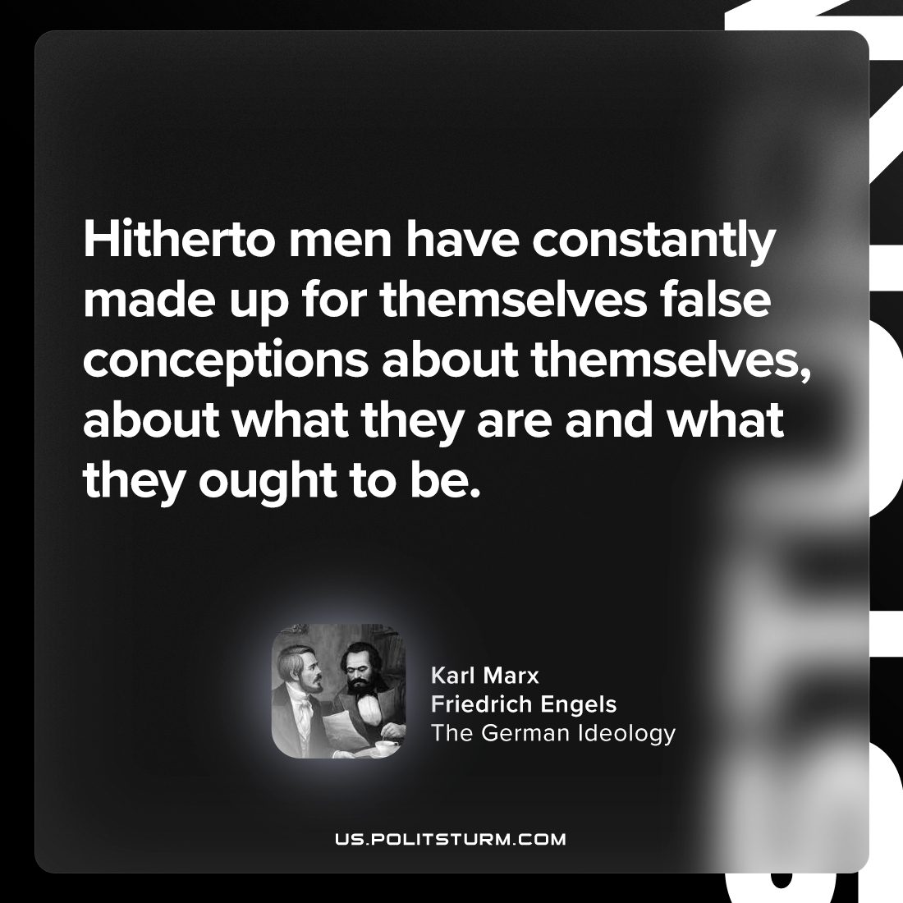

Original article
2024-05-09

"Hitherto men have constantly made up for themselves false conceptions about themselves, about what they are and what they ought to be."
Karl Marx and Friedrich Engels, The German Ideology

Original article

