Marx and Engels on how Communism Frees Man
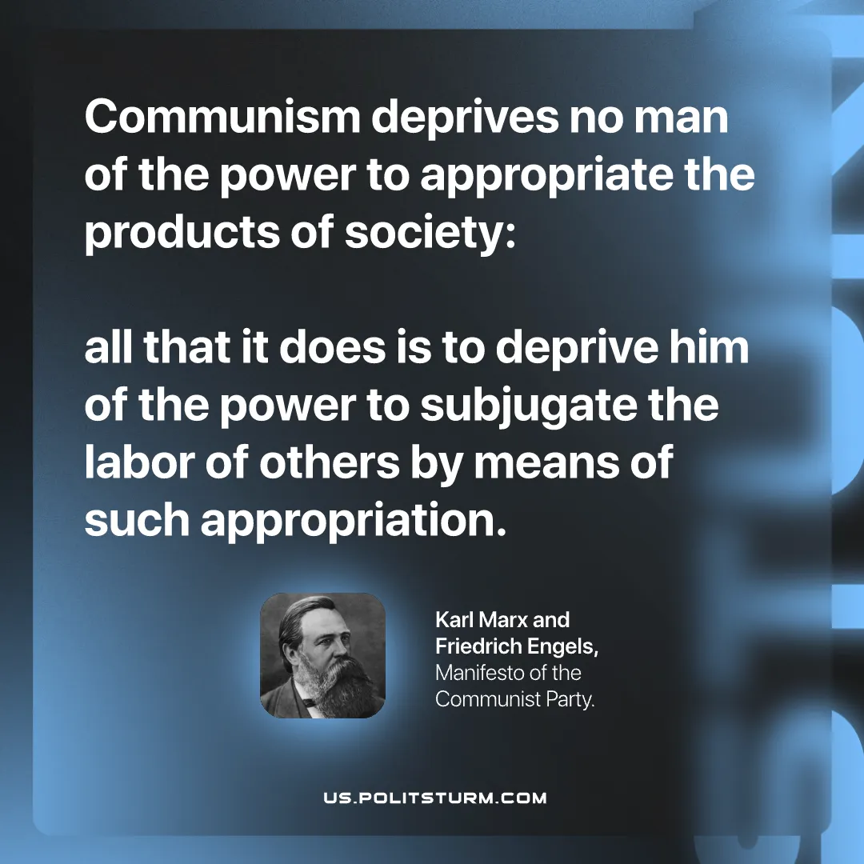

Original article
2026-06-28

Communism deprives no man of the power to appropriate the products of society:
all that it does is to deprive him of the power to subjugate the labor of others by means of such appropriation.
Karl Marx and Friedrich Engels, Manifesto of the Communist Party.

Original article

