Marx and Engels on History
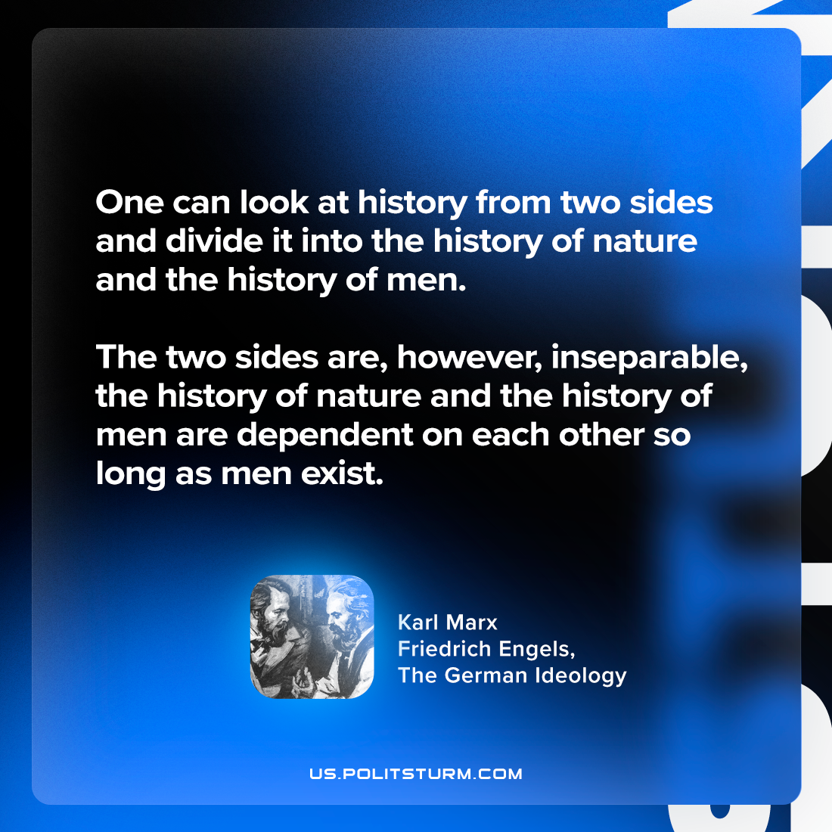

Original article
2024-05-11

"One can look at history from two sides and divide it into the history of nature and the history of men. The two sides are, however, inseparable; the history of nature and the history of men are dependent on each other so long as men exist."
Karl Marx and Friedrich Engels, The German Ideology

Original article

