Marx and Engels on Free Development Under Socialism
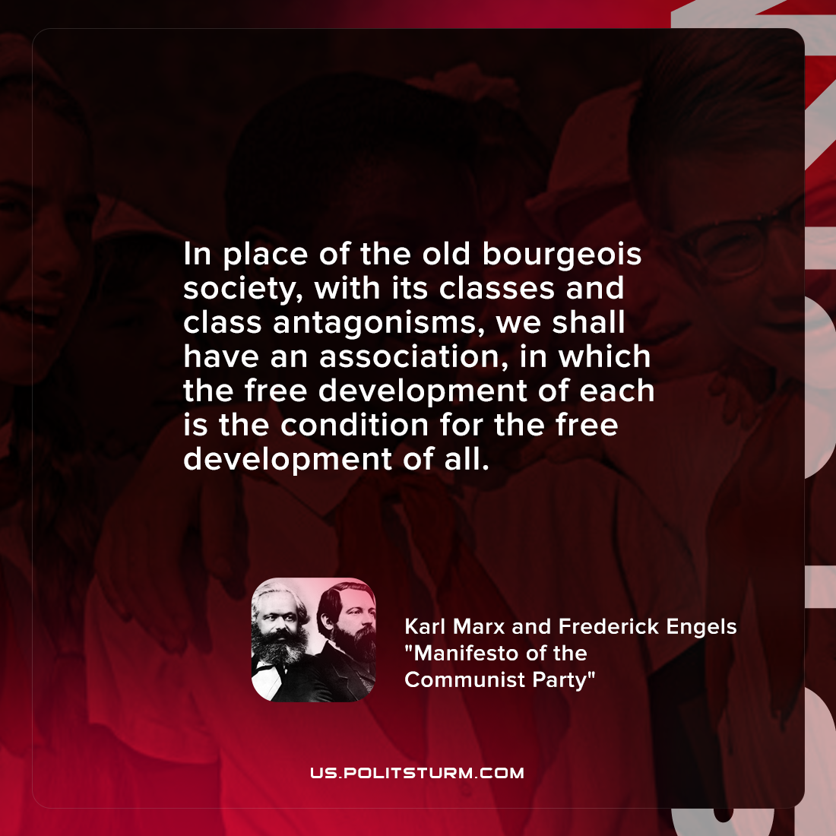

Original article
2022-02-20

In place of the old bourgeois society, with its classes and class antagonisms, we shall have an association, in which the free development of each is the condition for the free development of all.

Karl Marx and Frederick Engels, “Manifesto of the Communist Party”

Original article

