Marx and Engels on Free Development Under Communism
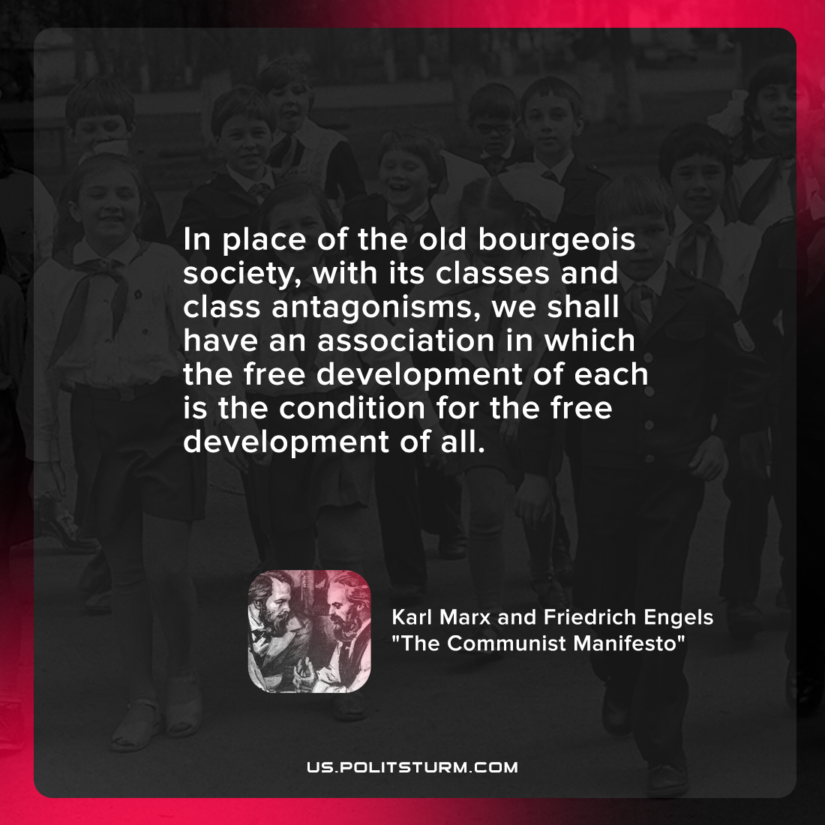

Original article
2022-01-19

In place of the old bourgeois society, with its classes and class antagonisms, we shall have an association in which the free development of each is the condition for the free development of all.

Marx & Engels, “Communist Manifesto”

Original article

