Marx and Engels on Family and Money Relations
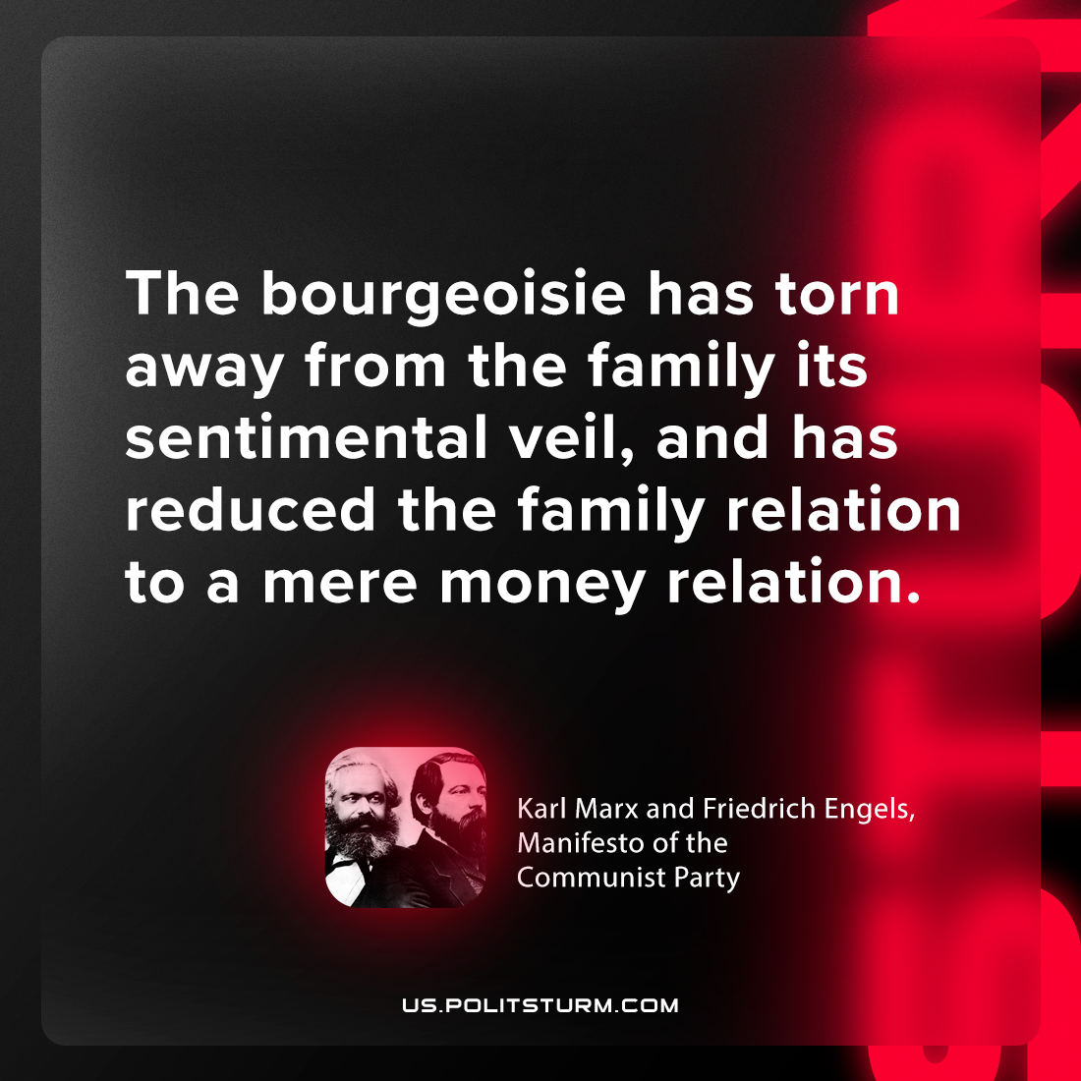

Original article
2024-03-12

“The bourgeoisie has torn away from the family its sentimental veil, and has reduced the family relation to a mere money relation.”
Karl Marx and Friedrich Engels, Manifesto of the Communist Party

Original article

