Marx and Engels on Expanding Markets for the Bourgeoisie
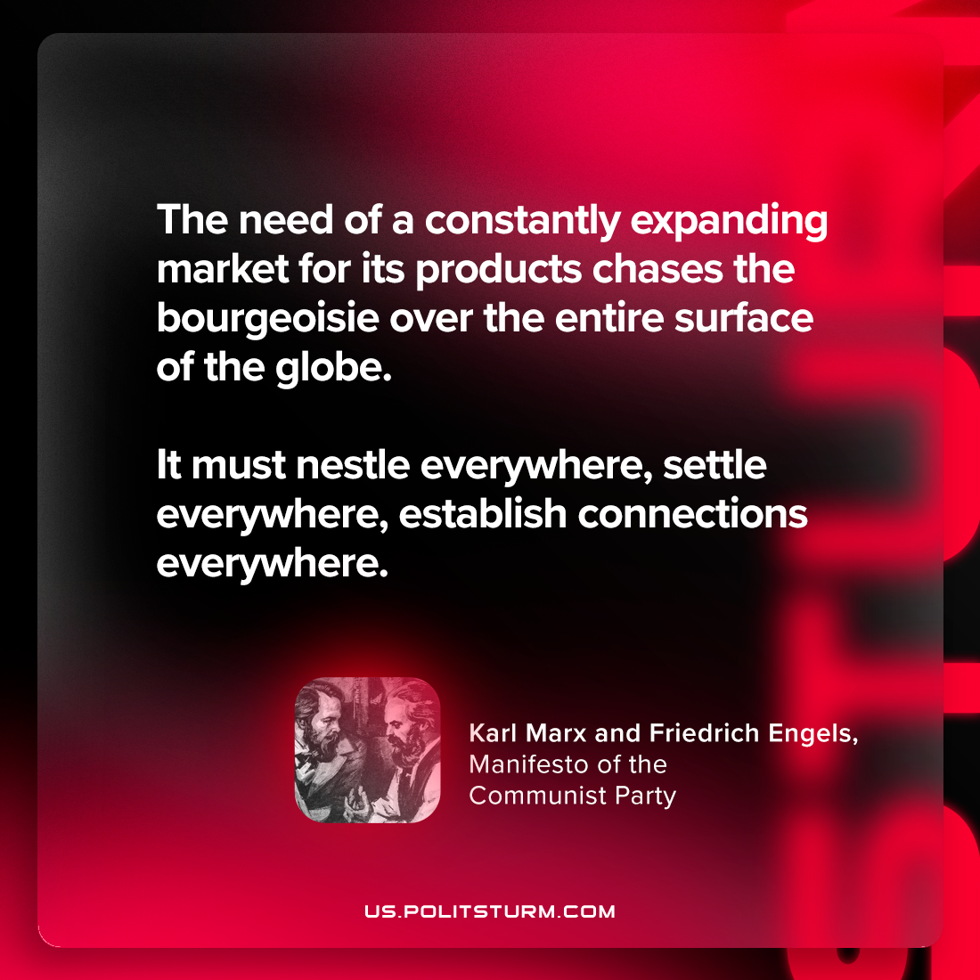

Original article
2023-12-19

"The need of a constantly expanding market for its products chases the bourgeoisie over the entire surface of the globe. It must nestle everywhere, settle everywhere, establish connections everywhere."
Karl Marx and Friedrich Engels, Manifesto of the Communist Party

Original article

