Marx and Engels on Bourgeois Treatment of Women
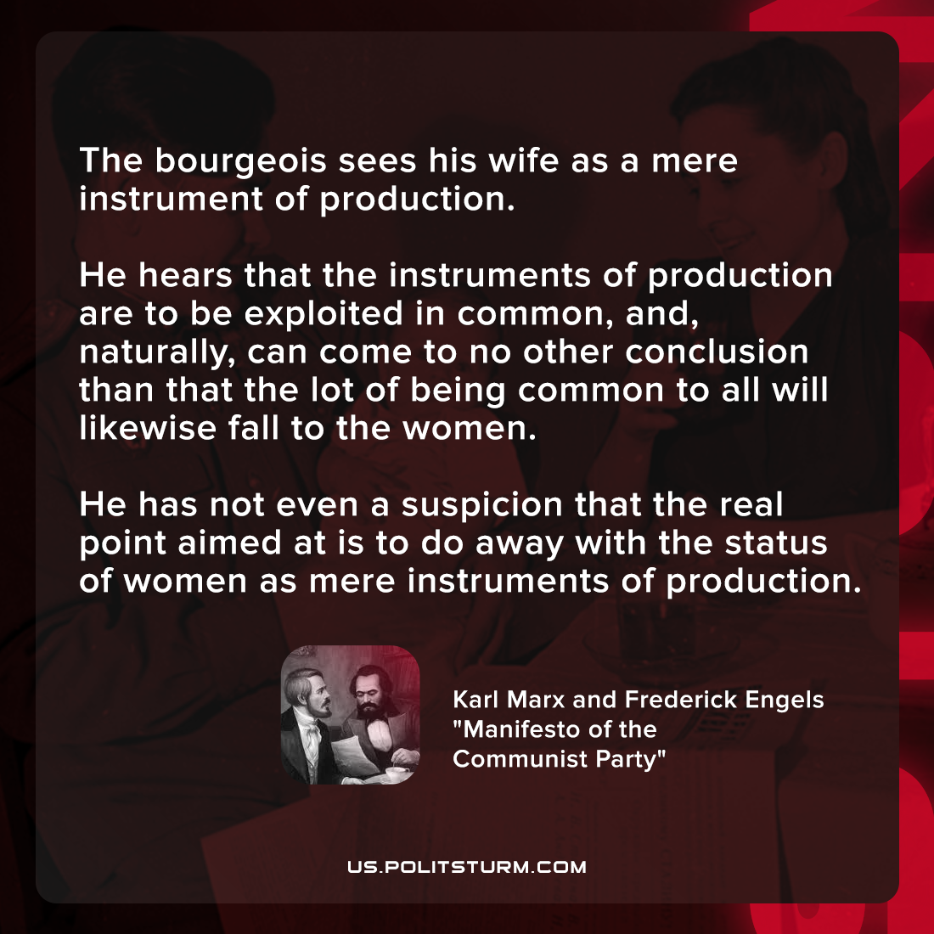

Original article
2022-02-22
1 min read

The bourgeois sees his wife as a mere instrument of production. He hears that the instruments of production are to be exploited in common, and, naturally, can come to no other conclusion than that the lot of being common to all will likewise fall to the women. He has not even a suspicion that the real point aimed at is to do away with the status of women as mere instruments of production.

Karl Marx and Frederick Engels, “Manifesto of the Communist Party”

Original article

