Martin Shkreli: Inglorious end of the bourgeois “Pharma Bro”
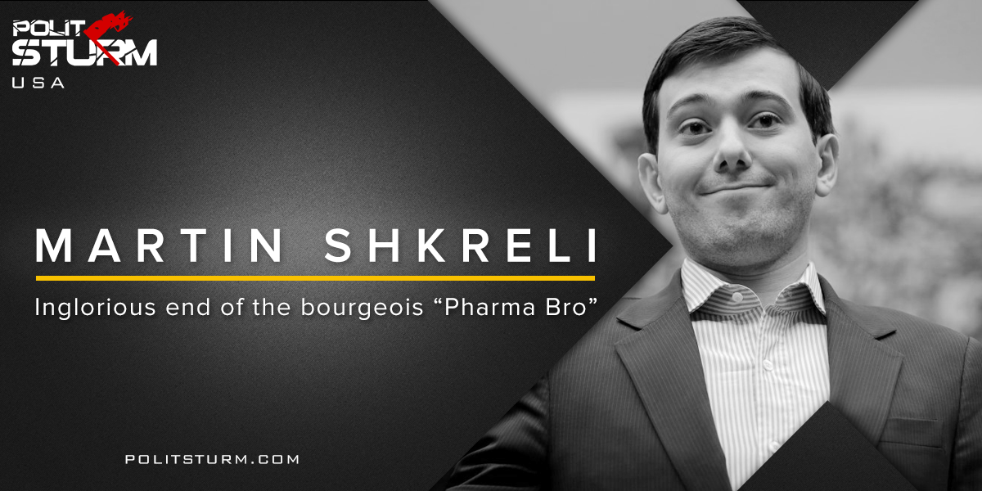

Original article
2018-03-17
7 min read

Martin Shkreli, the deplorable ex-executive of a major US pharmaceutical company and hedge fund manager, was convicted of misleading investors who lost investments in two hedge funds he operated. Shkreli was sentenced to seven years in prison, to forfeit more than $7.3 million in accounts and assets, and fined an extra $75,000. It was reported that Shkreli cried after being handed down the sentencing.
“There’s no conspiracy to take down Martin Shkreli,” he admitted in court. “I took down Martin Shkreli with my disgraceful actions.”
Known as the “Pharma Bro”, Shkreli became infamous in 2015 when he increased the price of a life-saving drug, Daraprim, by 5000%, from roughly $15 to $750 per pill. Shkreli’s company Turing acquired the drug after its 20 year patent expired and without any generic brands to compete with, Shkreli saw the chance to turn a large profit by jacking up the price. Overall, the pill costs less than a dollar to manufacture. Daraprim is taken to prevent malaria and fight infections that can arise from AIDS and cancer.
This was not the first instance of price gouging in the case of Shkreli. Under his leadership at Retrophin, he acquired the right to distribute tiopronin, a pill to treat a rare disease called cystinuria. Previous to his departure from Retrophin, he raised the price of the pill from $1.50 per pill to $30. Patients are expected to take 10 to 15 of these pills a day.
Shkreli is renowned for his “troll-like” behavior and his affinity for the rebellious bourgeois lifestyle. When asked on Twitter how he could sleep at night following the price-hike, unbothered by the outrage, he mocked the questioner, saying “You know, ambien.” Shkreli posted that it wasn’t his fault if middle and lower class people could not afford the drug, claiming that he deserved to be rich. Shkreli went viral when he bragged on different occasions of acquiring the only copy of the latest Wu Tang Clan and Lil Wayne albums for several million dollars. Even during the trial process Shkreli refused to be silent, offering $5,000 for anyone who could get a lock of then-presidential candidate Hillary Clinton’s hair.
Shkreli bragged on social media that he would never see time behind bars, and even if he did, it would be a few months in a minimum security “Club Fed” prison. After his conviction, he boasted to the New York Daily News that he’d “play basketball and tennis and Xbox and be out on these streets in four months.” However, Shkreli’s time in the Metropolitan Detention Center has hardly been a walk in the park. The MDC is home to defendants accused of joining the Islamic State group or committing attacks on their behalf as well as members of large criminal organizations. The prison is allegedly known for its strict living conditions; an absence of fresh air or sunlight and a total lack of any outdoor time and activities.”
The parable of Martin Shkreli is not one of justice but a clear account of the contradictory nature of liberalism’s societal values. Supporters of the neoliberal modernity are quick to point out that the “bad capitalist” got what was coming for him, which to a certain extent is true. What is lost on these detractors is that the arrest of Martin Shkreli was not on the grounds of price gouging, but for operating a Ponzi scheme. For many liberals, the shock that such an ‘evil’ individual could do such a thing sparked outrage, but the underlying notion of this anger is not with Shkreli, but all of the bourgeois values that liberals uphold. This contradiction between what we “know” is immoral and the faith we place in the market to distribute fairly, Shkreli’s own economic interests, and the dominance of the “Individual” over the “Society”, are at the heart of the Shkreli story. Shkreli’s decision may have caused many people significant financial burden and possibly even serious health problems because of his decision, yet, liberal ideology understands this to be his individual freedom that cannot be infringed upon or a side-effect of the market where little can be done. Based on the laws of the bourgeois-held state, the juridical institutions could do nothing to the extortioner on the grounds of private property protections. It was only after the fact, that the FBI coincidentally arrested Shkreli for a totally unrelated crime. Only when Shkreli mishandled the investments of wealthy investors that he could finally be taken down.
The disconnect between this somewhat obvious factor has clearly been “filtered out” by the corporate media. This depoliticization of the news, leaving class out of the final analysis, avoids this contradiction that would lead any rational individual to question the legitimacy of the economic system. Instead, the people are left with the same presupposed myths concerning the market. Its as Marx claimed in the German Ideology:
“The ideas of the ruling class are in every epoch the ruling ideas, i.e. the class which is the ruling material force of society, is at the same time its ruling intellectual force. The class which has the means of material production at its disposal, has control at the same time over the means of mental production, so that thereby, generally speaking, the ideas of those who lack the means of mental production are subject to it.”
We should remember that like in many cases involving pharmaceutical products this price hike did not come about after an extensive period of scientific research. There was no public benefit that came from him acquiring the drug, only the private benefit of accumulation.
And then there’s Shkreli’s new “Shkreli Foundation and online publicity stunt to donate $10k to an autism charity. Aside from the obvious attempt to buy himself a better public image, there is a fundamental problem in a system that allows, as Zizek put it, the capitalist to “repair with his right hand what destroys with his left hand.” Why do we heroize the capitalist for all of their philanthropic endeavors when the process in which they “earned” their money comes at a detriment to society? Dr. King came to this same conclusion later in his life when talking about making the shift from a “thing-oriented” society to a “person-oriented” society.
“True compassion is more than flipping a coin to a beggar; it is not haphazard and superficial. It comes to see that an edifice which produces beggars needs re-structuring. A true revolution of values will soon look uneasily on the glaring contrast of poverty and wealth.”
Finally, it’s in situations such as these that we discover to our horror that the “free” market is not always as free as we are to believe. When faced with the “choice” between spending money to save one’s health and risking serious injury to one’s life, people will always choose the former, no matter the cost. This is because this is a “non-choice”, a decision that ideologically presents itself as a free choice between two paths but in reality is “rigged” with certain social coercions.

Sources:
Dr. Martin Luther King Jr. “Beyond Vietnam: A Time to Break Silence”.
1, 2, 3, 4, 5, 6, 7, 8,

Original article

