Marriott Workers Win Higher Wages and Benefits
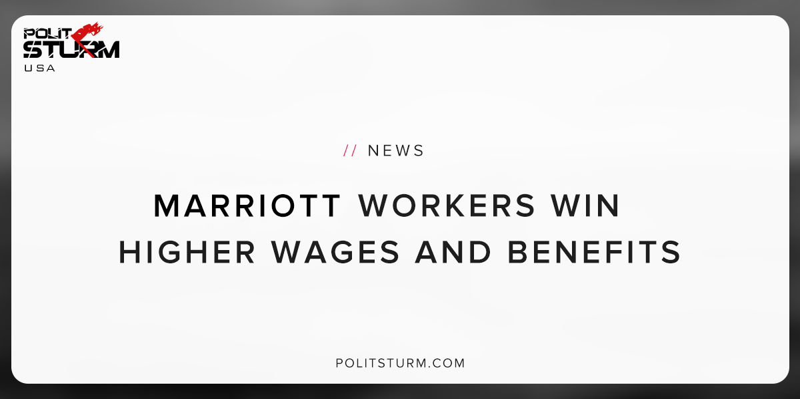

Original article
2018-12-01
1 min read

Marriott workers represented by the Boston Local 26 union received a new contract that included higher wages and new benefits. The hotel workers were on strike for 46 days before Marriott management proposed the new contract.
While the details of the new contract have not been publicly released, union officials have indicated that the contract includes job security benefits, increased wages, and a better benefits package.
The strike started on October 3rd, 2018 when 1,500 hotel workers walked off the job at seven Marriott-owned hotels across the city. This was the first strike by hotel workers in Boston’s history.
The slogan the workers used during their strike was “One job should be enough”, which highlights how workers were struggling to make ends meet with just one job in an area with such a high cost of living.
John Elrod, a Marriott employee, said “The hotel industry needs to pay its workers a fair and living wage. “
Marriott has been rapidly expanding its revenue, profits, and assets after purchasing the Starwood hotel chain in 2016, and the workers knew this.
Workers can see that the capitalists are increasing their profits, but wages were stagnant. The Marriott management represents the interests of the shareholders, bondholders, and corporate executives. This explains why it was necessary for the workers to organize to represent their own interests against the capitalist class.
The capitalist class did not capitulate to the demands for higher wages, benefits, and job security until the workers went on strike for an extended period of time. The workers at Marriott have demonstrated how successful organization of the working class can achieve tangible success against the resistance of the capitalists.
This victory, as important as it is, is only a temporary victory. In order to achieve long term success it will be necessary to increase the organization of the working class, against the capitalist class.
Sources: 1 2 3

Original article

