Marriott Hotel Workers Strike In Downtown Boston
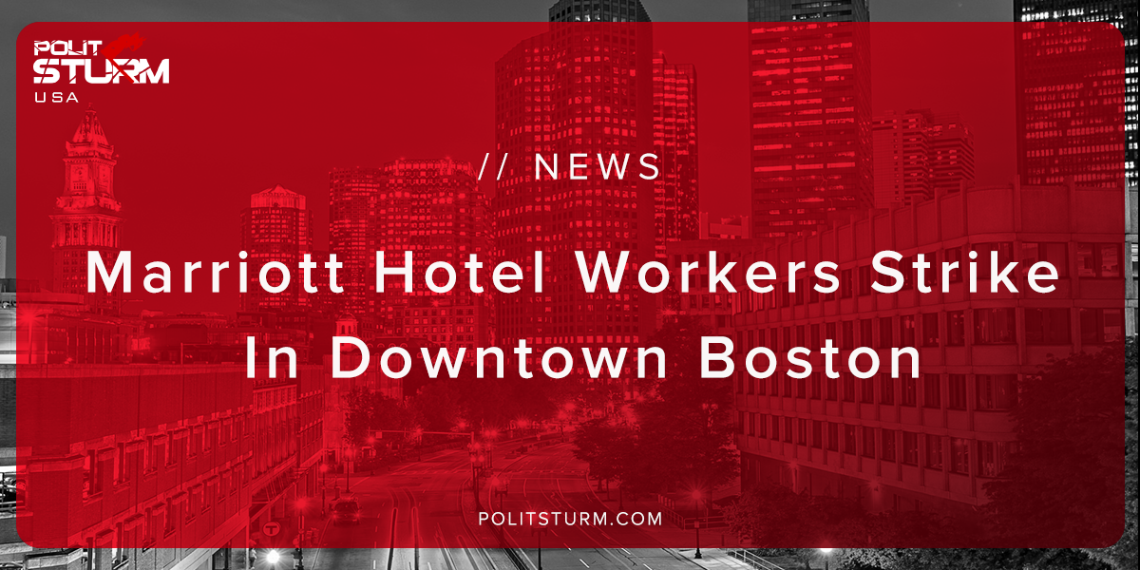

Original article
2018-10-22
1 min read

Marriott workers went on strike in downtown Boston this Friday afternoon as they walked out of the hotels with picket signs and drums This is the first hotel workers strike in the city’s history according to the Boston’s Local 26, the union representing the workers.
The strikers consist of housekeepers, cooks, bartenders, bellmen, food and beverage servers, and dishwashers. The workers were employed at 7 Marriott-operated hotels around the city.
The strike conditions arose because Marriott was unwilling to compromise to the union’s demand of “One Job Should Be Enough”. Many workers are forced to work several jobs in order to cover basic living expenses. Marriott, after several months of negotiation, failed to provide any meaningful concessions to the workers in terms of increased wages and benefits.
“I am striking because I have to work three jobs to try and cover all my family’s expenses,” said Brooke Melanson, a bartender at the Westin Boston Waterfront. “Just like any parent, I want time with my children to see them grow up. We hear all the time how well Marriott is doing. We want Marriott to recognize our contribution to their success.”
Marriott reported an increase in its earnings per share for its stockholders of 34% since last year. The workers know that the increased financial results have benefitted shareholders and corporate executives, but not themselves.
Marriott aces potential strikes in San Francisco, Detroit, Seattle, San Jose, San Diego, Oakland, and Hawaii according to the union.
Sources: 1 2

Original article

