Mussolini's March on Rome Funded and Coordinated by the British State
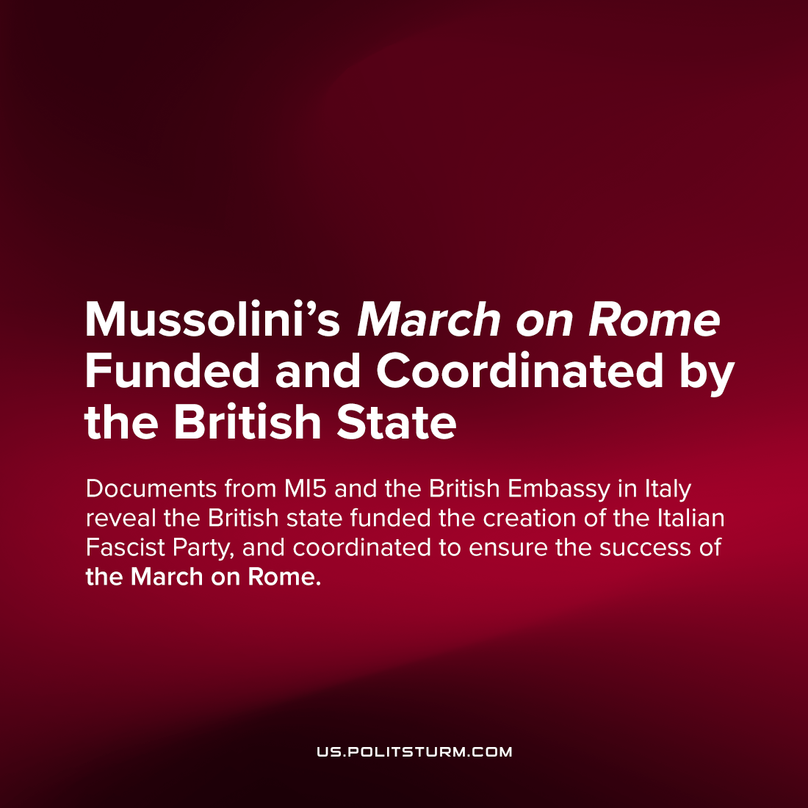

Original article
2022-10-06
3 min read

Years ago, it was revealed from Cambridge archives that Mussolini was an agent of British foreign intelligence, paid $6,000 a week from 1917-1918, to promote what Lenin would denounce as nationalist chauvinism in support of WWI within the socialist camp.

…we have repeatedly pointed to this most profound connection, the economic connection, between the imperialist bourgeoisie and the opportunism which has triumphed (for long?) in the labour movement. And from this, incidentally, we concluded that a split with the social-chauvinists was inevitable.
V. I. Lenin, 1916
Imperialism and the Split in Socialism
While this thunderous revelation was never fully absorbed into the general consciousness, it is cited by the authors of a new essay, Nero di Londra, as inspiring their pursuit of Mussolini’s further connections to British intelligence. They explore the archival discoveries of historian Peter Martland, who revealed that MI5’s man in Italy, Sir Samuel Hoare, authorized Mussolini’s weekly allowance.
Other documents go on to reveal the extent of British foreign interference in Italian politics, which fought to push Mussolini into leadership by any possible means.
In the political chaos of Italy at the end of WWI, the head of the Directorate of Military Intelligence in Italy, Sir Hoare, sought to keep Italy fighting against Britain’s Central Power enemies. But when the war was over, they did not forget about their agent.
The British liaison for the project to create fascism in Italy had extensive experience in the use of violence and propaganda against left-wing movements, through the Anti-Socialist League in Britain. These tactics, Sir Hoare took to Mussolini, and offered him and his allies enough money to carry them out, and to, in Sir Hoare’s own words, “form the Fascist Party and to finance the march”
One author writes:
“Mussolini’s career between 1917 and 1922 would not have taken the path we know without the influence of the British conservative establishment.”
As Mussolini’s prominence grew to its height, and fascists threatened to seize power in Italy by force, the British Embassy became more and more involved. In the days before the March on Rome, which would pressure the King to nominate Mussolini into power without an election in the historic vanguard success of international fascism, the British Ambassador to Italy stayed in constant contact with the March’s organizers. As the events unfolded, Ambassador Graham informed the fascist leadership about the effect of their march, cautioning and encouraging them with the facts of their likely success. These same organizers plotted in the home of a prominent British-Italian aristocrat.
It is in this context we must view Churchill’s loud praise of the rise of Mussolini to absolute power – as a man who knew British silver carried him there. The essay’s authors identify this plan with the early formation of NATO’s ‘strategy of tension’ – in which military and state intelligence funded fascist armed groups in Europe in the latter 20th century.
While the authors point out that further documents are still hidden in the Naval Intelligence archives in London, this flood of releases comes in a historic political moment, in which the entire legitimacy of government is in question. The only hope for the capitalists is that the importance of these historic will be ignored by its politically polarized citizenry, who are hoped will either stick to their dogged allegiance and dismiss claims like this which seem ‘wild’, or simply add this issue as one more reason to distrust the ‘crony state’ and move on with their same loyalties to the state’s underlying structure.
Fascism is simply a development of capitalism itself, in its most chauvinistic and imperialist form. So, we must not be surprised when we uncover more and more direct relations between the old kind of capitalist dictatorships in Britain, and the new kinds invented in Italy. The greatest importance lies in bringing these revelations to the masses, facilitating their ongoing awakening.
Sources: 1.

Original article

