Mamdani Wins New York Election
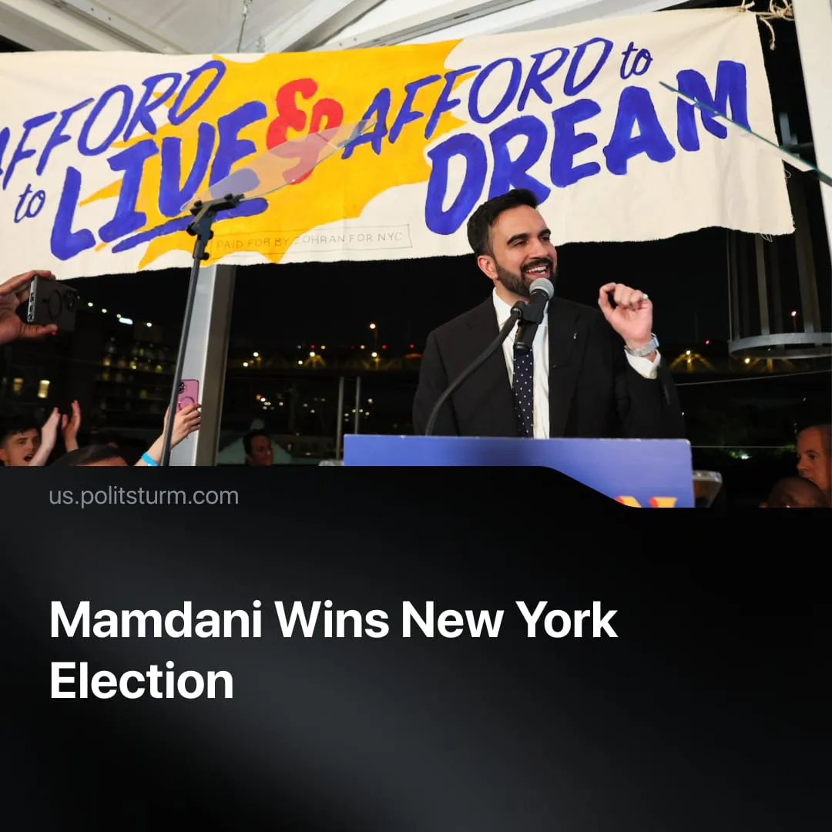

Original article
2025-11-06
2 min read

Mamdani's victory was supported by billionaire Democrats and does not pose a serious threat to Trump.
Details. In the US, Democratic Party candidate Zohran Mamdani won the New York City mayoral election by 50.4%, defeating both the former governor Andrew Cuomo (independent) and contender Curtis Sliwa (Republican Party).
► 2 million New Yorkers voted in this election, the highest number since 1969, with turnout rising to 38% – the best since 2001. This nearly doubled the previous election’s 23%, though the majority of eligible voters still abstained.
► Mainstream media outlets labelled Mamdani’s election a “historic win” for the so-called progressive left within the US Democratic Party.
Context. Mamdani, a former housing counsellor and local politician and member of the “Democratic Socialists of America,” gained fame by beating Andrew Cuomo in the Democratic Party primaries with a left-wing campaign focused on “affordability”, proposing social-democratic reforms such as rent freezes, universal childcare, and free buses.
► Although Mamdani styles himself a “socialist” and claims to oppose billionaires, he recognises the “important role” of the private sector and approached capitalists to support him. Mamdani met with 150 business leaders, courted billionaire Michael Bloomberg and won the tacit support of Jamie Dimon – billionaire CEO of JPMorgan Chase Bank.
► Polls show most Americans no longer view capitalism positively – a sentiment Mamdani redirects into preserving faith in bourgeois democracy, which he says is “under attack from a withering faith in its ability to deliver on these material challenges in working-class people’s lives.”
► Trump and the Republican Party reacted very aggressively to Mamdani’s campaign, with the President falsely branding him "100% communist lunatic" and threatening to withhold federal funds from New York should he win. Trump has previously suggested deploying the military in New York City as his regime has done in Los Angeles, Washington and Seattle.
Important to Know. As mayor of New York City, Mamdani will have some municipal powers to affect local policies (albeit restricted by the city’s bourgeois Charter). However, major issues such as education and the subway system are under the purview of the State Governor. Furthermore, New York City receives $10 billion in federal funds controlled by President Trump. Mamdani will not have the power to change essential things, transform the USA or challenge capitalism.
► Mamdani’s victory will likely be praised by Democrats and liberal media as an example of the fight for "restoring democracy" against the fascisation of the US that intensified under Trump. Historically, electing Democrats such as President Joe Biden didn't change the essence of the American government. In the case of New York City, former mayors such as Fiorello La Guardia pursued similar social-democratic policies to Mamdani, which have since been rolled back.
► This phenomenon of social-democrats winning local elections, without threatening the capitalist system, was already present a hundred years ago. Lenin offered a particular critique: “If the bourgeoisie allows, tolerates, “municipal socialism”, it is because the latter does not touch the foundations of its rule, does not interfere with the Important sources of its wealth, but extends only to the narrow sphere of local expenditure, which the bourgeoisie itself allows the “population” to manage... any attempt on the part of socialist municipalities to go a little beyond the boundaries of their normal, i. e., minor, petty activities, which give no substantial relief to the workers, any attempt to meddle with capital, is invariably vetoed in the most emphatic manner by the central authorities, of the bourgeois state."

Original article

