How Mamdani Strengthens the Far-Right
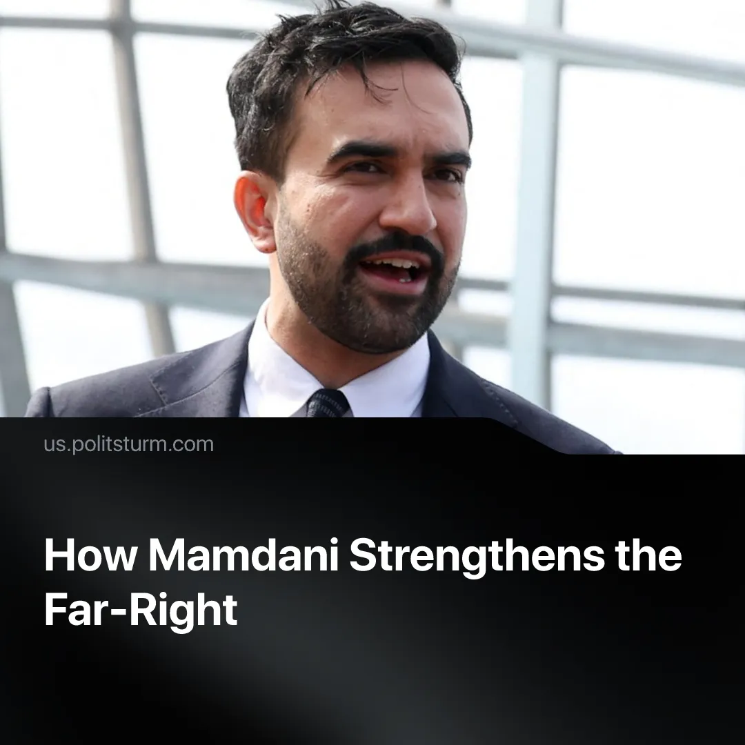

Original article
2025-12-03
2 min read

How can figures like Mamdani end up strengthening the far-right?
Details. Zohran Mamdani is the current governor of New York, who describes himself as a “democratic socialist” and a member of the Democratic Party’s left wing alongside figures like Bernie Sanders and Alexandria Ocasio-Cortez.
► He and his group have promised to tackle social and economic inequality. They plan on freezing rent prices, raising taxes on the ultra-wealthy, making public bus service free, and improving the living conditions of the American workers in general. With these moderate reforms, they plan to restore faith in democracy and the Democratic Party.
► So-called “Marxists” and “socialist organisations” have opportunistically argued that the victory of candidates like Mamdani is tactically useful because his “positive narrative on socialism” can draw left-leaning voters and broaden their influence.
Context. US workers’ disapproval of the current regime has grown, reflected in a wave of strikes, walkouts, and mass rallies. The nationwide “No Kings” actions, the Labour Day “Workers over Billionaires” marches, spontaneous protests in Los Angeles and Chicago against immigration raids, police repression and federal intervention all drew thousands. Although in many instances these were led by Democrats or the liberal left, they are a reflection of sharpening class antagonisms.
► Since there’s no strong communist organization in the US, figures like Mamdani hold a monopoly over the meaning of words like “socialism”, aided by conservatives who frequently associate Mamdani with communism – blurring the line between social-democracy and genuine socialism.
Important to Know. Support for Mamdani does not raise class consciousness; it redirects workers’ hopes into the capitalist parliamentary system, reinforcing the dominance of capital over labour. Social Democrats like Mamdani are at best misguided reformists and at worst conscious enemies of the working class, tied to and defending the Democratic Party.
► The result is that some frustrated workers are drawn to a rising far-right, attracted by its promise of radical change, while others become demoralised and retreat from politics and resistance to fascism. This dynamic is evident today in the rise of far-right movements across Europe and in both of Trump’s elections, where left reformist parties offered no meaningful improvements to workers' lives.
► This has happened before. The lack of a strong communist organisation and the limited reforms of the US President Jimmy Carter failed to prevent high inflation, unemployment and energy crisis, leading to Ronald Reagan’s election in 1980. Once in office, Reagan promised to reject the "insufficient" reforms and deregulate the economy. Similarly, after a Labour Government which saw stagflation and industrial unrest, Margaret Thatcher rose on a campaign of implementing privatisation, deregulation and a weakening of union power by banning sympathy and political strikes.
► In a more extreme historical example, Germany had a strong communist movement which was then betrayed by the social democrats who defended the existing capitalist order, reforms, helped suppress revolutionary workers and execute their leadership. This weakened and divided the left, leaving many workers demoralised and passive in the face of crisis, and ultimately helped to facilitate Hitler’s rise to power.

Original article

