Major Strikes in the US in 2019
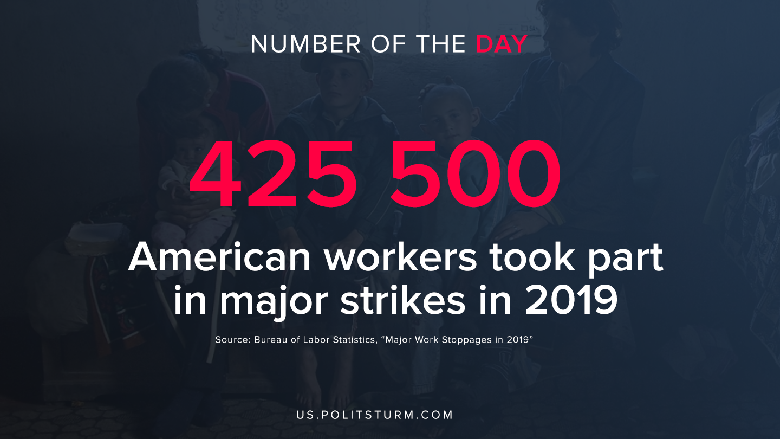

Original article
2020-02-25

Source: Bureau of Labor Statistics, “Major Work Stoppages in 2019”

Original article

