Major Companies Increase Dividends and Stock Buybacks
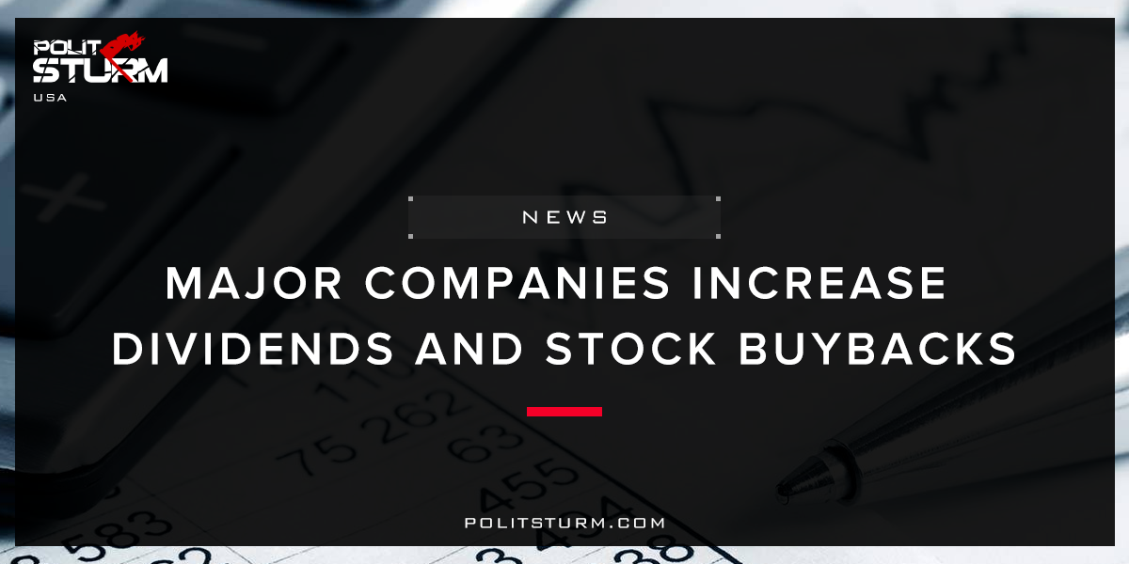

Original article
2018-02-23
2 min read

Waste Management CEO Jim Fish on CNBC Friday disputed the narrative that major companies are using most of the new corporate tax cut to buy back stock.
Fish cited the trash and recycling giant’s plans as case and point, saying the company he leads is giving special bonuses of $2,000 to about 34,000 employees. He also said the tax cut windall will be used to purchase new equipment.
“So about three-quarters to 80 percent of it is going to go back into the economy. And we think it will benefit shareholders on the back end of the cycle,” Fish told “Squawk Box.”
The new tax law, championed by President Donald Trump and Republicans on Capitol Hill, reduces the federal corporate tax rate from 35 percent to 21 percent.
“The benefit to us was about $275 million,” Fish said. “We gave about $70 million back to employees through a bonus. And we’re spending an extra $150 [million] by accelerating some spending on trucks and some IT spends.”
“We like what tax reform has done for us so far,” he said. “We’re a pretty good barometer of the economy. We see it on just about every sector of the economy, whether it’s the industrial or the services side. Right now, we’re seeing a very good economy.”
Politsturm: The capitalist class is trying its hardest to portray the recent tax cuts as beneficial for the working class. The major narrative that this particular CEO is disputing is that companies have not been using the money saved from tax reductions to buy back stock and increase dividends. The fact of the matter is that almost immediately after the tax bill passed, Waste Management’s board of directors announced an increased dividend for its shareholders ($1.70 to $1.86 per share). At the same time, it announced that it would be buying back $1.25 billion in company stock. This has the effect of enriching those who happen to hold many shares of stock; the bourgeoisie.
While the leisure class of the parasitical oligarchs get increased dividends, the working class will receive less funding to food stamps, public health care, and education. The CEOs and boards of directors have no responsibility to serve the interests of the working people. The capitalists as a class will protect their own interests. It is in their interest to reduce their tax burden and increasing profits which serves as their lifeblood. No matter how much the CEOs try to dispute these facts is irrelevant. It is utter nonsense to think that the government is “broken” and that the proper bourgeois politicians could fix these grave contradictions of capitalism. The government supports the capitalist and landlord classes, while it stands in direct opposition of the working class. Only a government controlled by the working class would be able to tangibly improve the living conditions of the working class.
Sources: 1, 2

Original article

