MAGA Drafts Emergency Powers Bill for Trump’s Control of Elections
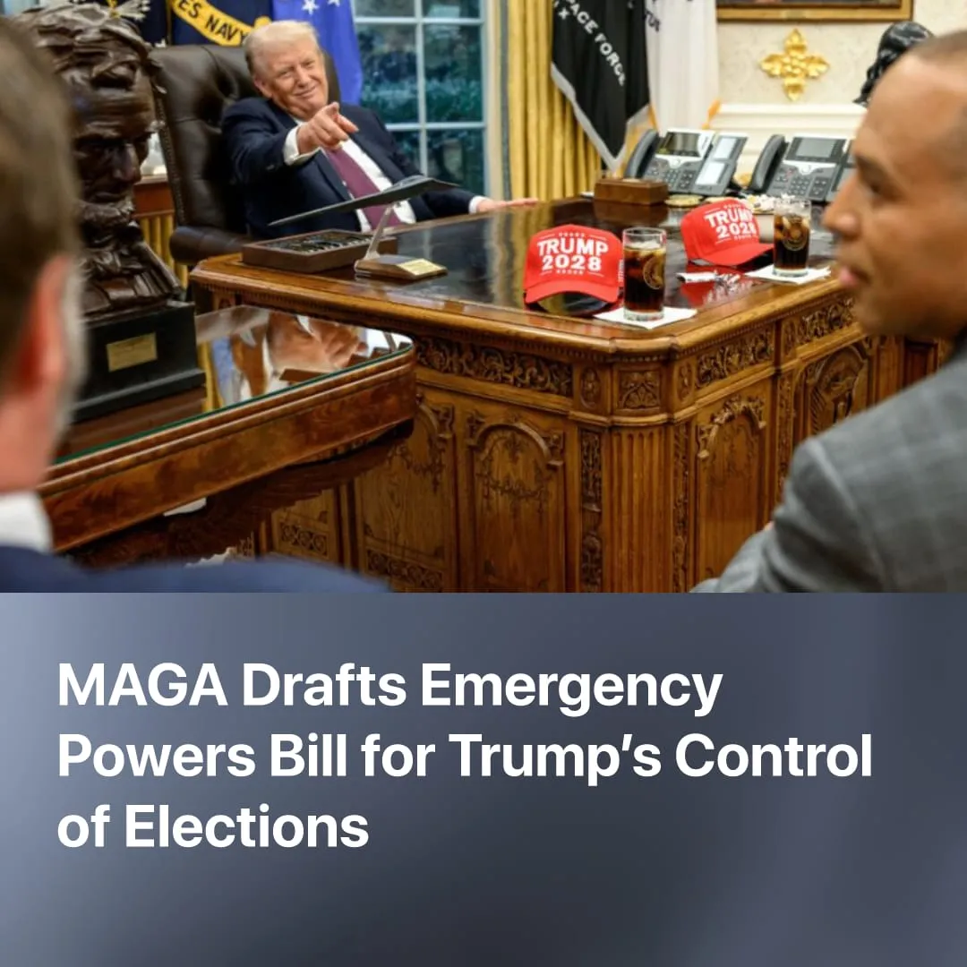

Original article
2026-03-16
2 min read

Trump administration moves to consolidate presidential power over elections before midterm elections.
Details. A lawyer close to President Trump has written a draft executive order, currently circulating in Washington, that declares a national emergency to enforce direct federal control over US elections.
► The proposed draft replaces the current process and would require physical birth documents or passports, a strict photo ID, and the assignment of a "National Unique Voter Number" to track voters across federal and state databases. If implemented, this could force a massive re-registration effort, creating significant administrative barriers for voters.
► If enacted, the draft would radically overturn the US constitutional tradition of state-run elections, centralising control in the federal executive for the first time in history.
► The legal justification for this attempt at the midterm election is a pre-emptive “national emergency” regarding alleged foreign interference from China.
Context. The Trump administration has been accelerating US fascisation, with the executive repeatedly bypassing both Congress and state governments. ICE agents were granted “federal immunity,” and police forces, along with the National Guard, were federalised and deployed against domestic protests. Recently, Trump has also publicly criticised the Supreme Court for blocking his tariff rulings and announced additional global tariffs.
► The US has historically used foreign enemies to justify fascisation. In this executive order, Republicans claim China stole the 2020 election, while previously, Democrats claimed Russia stole the 2016 election. In the context of the new US-Iran conflict, the FBI has claimed that terrorist “sleeper cells” could emerge on US soil, suggesting that alleged foreign threats may be invoked to justify further domestic crackdowns.
► Trump remains deeply unpopular, with over 60% of Americans disapproving of his leadership and 58% opposing the Iran conflict. Nevertheless, sections of the capitalist class that support his administration’s more hawkish methods may push for further concentration of executive power as a means to try to restore their waning global hegemony.
► Trump has repeatedly joked or suggested suspending elections. In January 2026, he told Reuters, “When you think of it, we shouldn’t even have an election,” regarding potential midterm losses. Earlier, in reference to Ukraine not holding elections under martial law, he rhetorically asked about suspending elections in the US and asked Zelensky if he liked the idea.

Original article

