Maduro’s Secret Concessions to US Imperialism
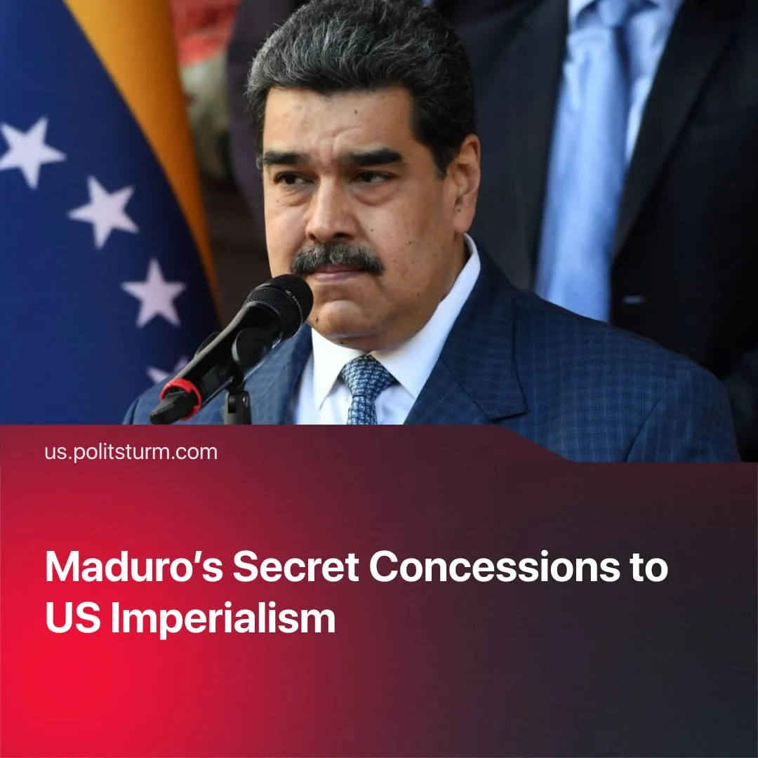

Original article
2025-10-16
1 min read

Venezuela’s vast natural resources would be handed over to the US in an offer made by the self-proclaimed “socialist” government of Nicolás Maduro.
Details. Venezuela has reportedly secretly offered the Trump administration a dominant stake in its oil and diverse mineral resources through preferential contracts with American corporations. The New York Times report is based on interviews with US and Venezuelan negotiators who spoke on condition of anonymity.
► The discussions reportedly included redirecting Venezuelan oil exports from China to the US, terminating contracts with Chinese, Russian, and Iranian firms, and halting fuel shipments to Cuba.
Context. The offer appears plausible since Venezuela’s “Bolivarian” government isn’t alien to previous secret talks and concession offers to the US. Far from defending “socialism,” it pursues a nationalist-bourgeois policy of survival through compromise with foreign capital.
► In 2017, amid new US sanctions, Maduro publicly appealed to Trump for direct talks, saying both governments could reach a mutual understanding “face to face.”
► In 2019, as Washington intensified support for Juan Guaidó, the opposition leader recognised by the US as interim president, Caracas engaged in secret back-channel talks with US officials seeking to ease pressure and normalise relations.
► In 2023, secret meetings between US and Venezuelan officials in Qatar again focused on easing sanctions in exchange for limited oil cooperation.
► The latest secret talks follow a US deployment of a naval force near Venezuela, including seven warships, a nuclear-powered submarine, and more than 4,500 military personnel. In response, President Maduro ordered the mobilisation of 4.5 million militia fighters.

Original article

