Macron Summons Opposition Leaders to Agree on Imperialist Foreign Policy
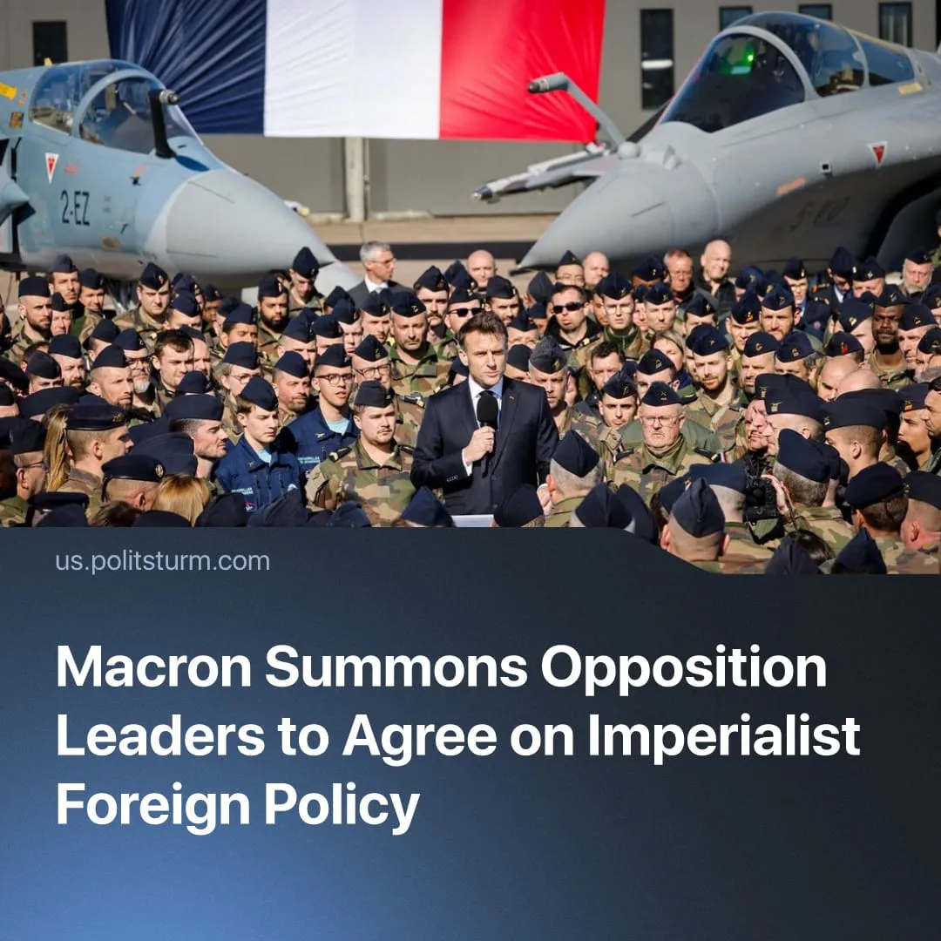

Original article
2026-09-30
2 min read

Ahead of elections, rival wings of France’s capitalist class meet to coordinate their imperialist war plans. This situation replicates the build up to World War 1.
Details. Outgoing French President Emmanuel Macron formally summoned rival political parties, including the far-right National Rally (RN) and the "leftist" France Unbowed (LFI), to a September 18 briefing at the Élysée Palace to jointly discuss the “rapidly degrading international situation”.
► Held behind closed doors in France’s high-security underground command bunker, the meeting covered the threat of the escalating “Special Military Operation” in Ukraine and the Middle East crisis. Macron reportedly shared classified intelligence on Russian plans to attack Europe, and outlined French response options. Afterwards, he announced France is raising its military “vigilance” and “securing our logistics chains and supplies” amidst wartime disruptions.
► The primary briefing to politicians was delivered not by elected officials, but by the directors of French military intelligence and domestic security. Following their assessment, Macron personally clarified his administration’s geopolitical strategy to the assembled party leaders, stressing the need for a unified national bourgeois response to manage these worsening imperialist crises.
► Both RN and LFI willingly sent their top officials, instantly dropping their populist “anti-Macron” posturing to sit with his generals. Jordan Bardella, president of the far-right RN, attended without complaint. Following the briefing, his party issued a statement condemning Russian acts of hostility and declaring they consider Moscow's actions a “very serious” threat that France must actively counter.
► Similarly, the "leftist" LFI dispatched its national coordinator, Manuel Bompard. While LFI often postures as a staunch anti-war movement, Bompard quietly took his seat at the military briefing. Exiting the Élysée, he offered no resistance to the militarist escalation, merely telling reporters he was not "less anxious" because the briefing vaguely confirmed a "durably degraded international situation”.
Context. A major global conflict is in the works, and bourgeois governments across the world are intensifying preparations for it. Under Macron, France remains a dominant regional imperialist power, actively leading efforts to construct a European "coalition of the willing" (involving countries prepared to deploy troops to Ukraine) and aggressively expanding its nuclear posture to “defend” against Russia, backed by massive increases in military spending.
► In the lead-up to war, the facade of bourgeois democracy is giving way to concrete state militarization, bypassing parliamentary dissent. “Opposition” parties have completely abandoned resisting this escalation, with the far-right RN backing a record €436 billion military budget, and with “leftist” LFI (alongside the “Communist” Party) merely offering lukewarm criticism of the new conscription plan and expanded executive war powers.
Important to Know. The masquerade of parliamentary opposition is always dropped during wartime. At the outbreak of World War 1, the French "Sacred Union" political truce and German "castle peace" (suspending party conflicts) saw all rival bourgeois factions in those countries unite to support their national war efforts – with even reformist and so-called “Marxist” parties like the SPD notoriously voting to fund the imperialist slaughter.
► Lenin analyzed this total capitulation at the 1915 Zimmerwald Conference in Switzerland, where communists gathered to rebuild the anti-war movement. He denounced the defencist parties who joined the “Sacred Union”, explaining that their social-chauvinist lie of "defending the fatherland" inevitably "leads to the abandonment of the class struggle", forcing workers to pay for war credits and sacrifice themselves for the imperialists’ profits.

Original article

