Marx on Changing the World
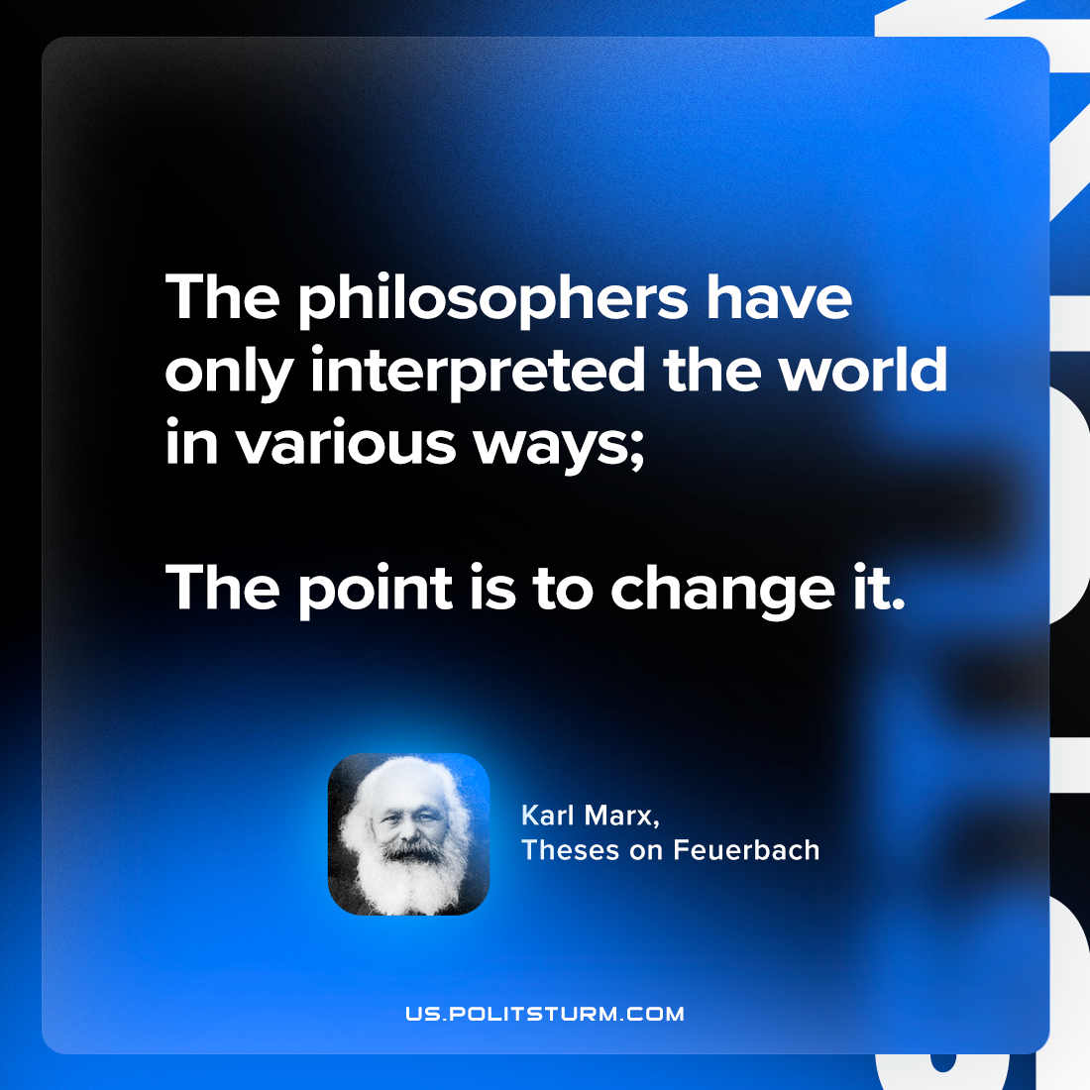

Original article
2024-06-16

"The philosophers have only interpreted the world in various ways; the point is to change it."
Karl Marx, Theses on Feuerbach

Original article

