Marx on 'Progress' Under Capitalist Agriculture
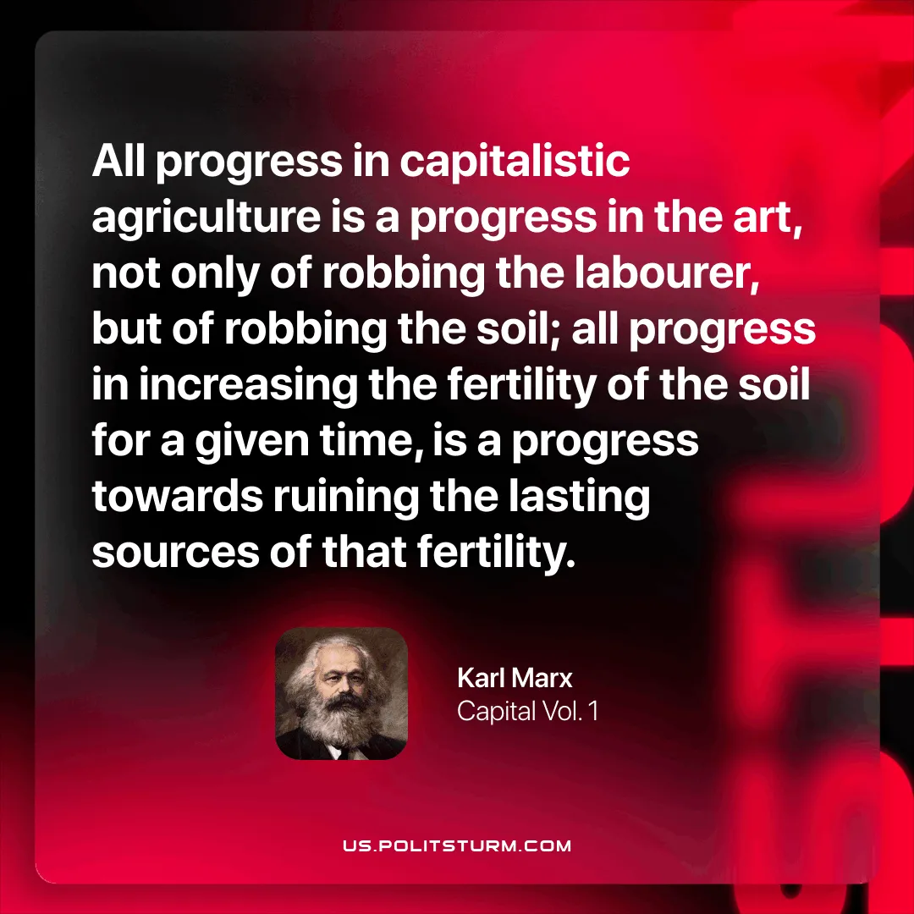

Original article
2025-11-13

“All progress in capitalistic agriculture is a progress in the art, not only of robbing the labourer, but of robbing the soil; all progress in increasing the fertility of the soil for a given time, is a progress towards ruining the lasting sources of that fertility.”
Karl Marx, Capital Vol. 1

Original article

