Marx and Engels on Communism
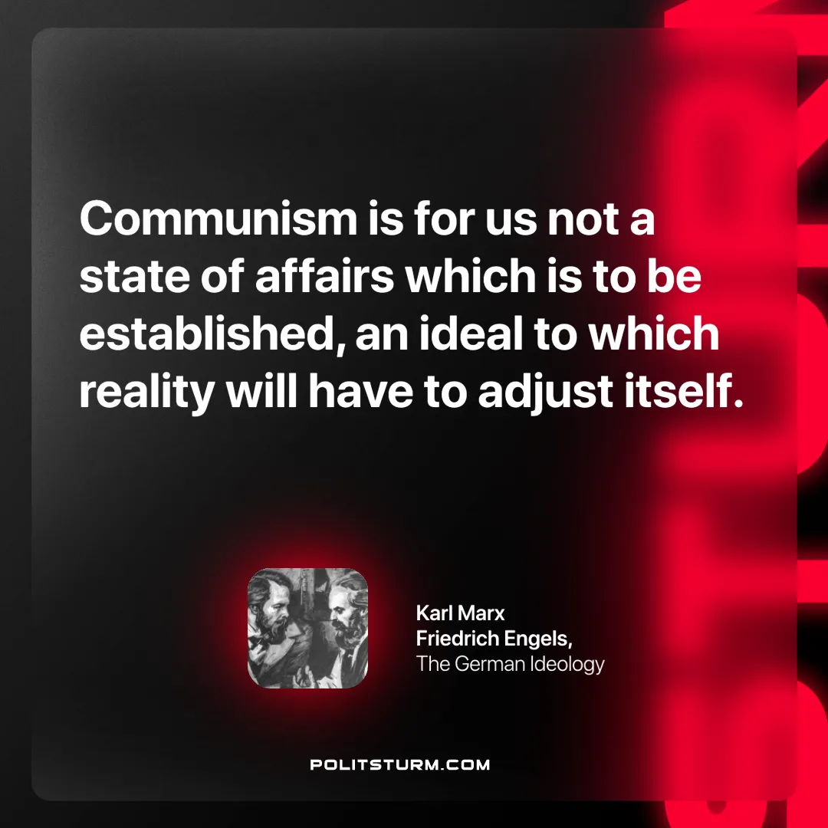

Original article
2024-12-01

“Communism is for us not a state of affairs which is to be established, an ideal to which reality will have to adjust itself.”
Karl Marx and Friedrich Engels, The German Ideology

Original article

