Marx and Engels on the Proletarian Revolution as a National Struggle
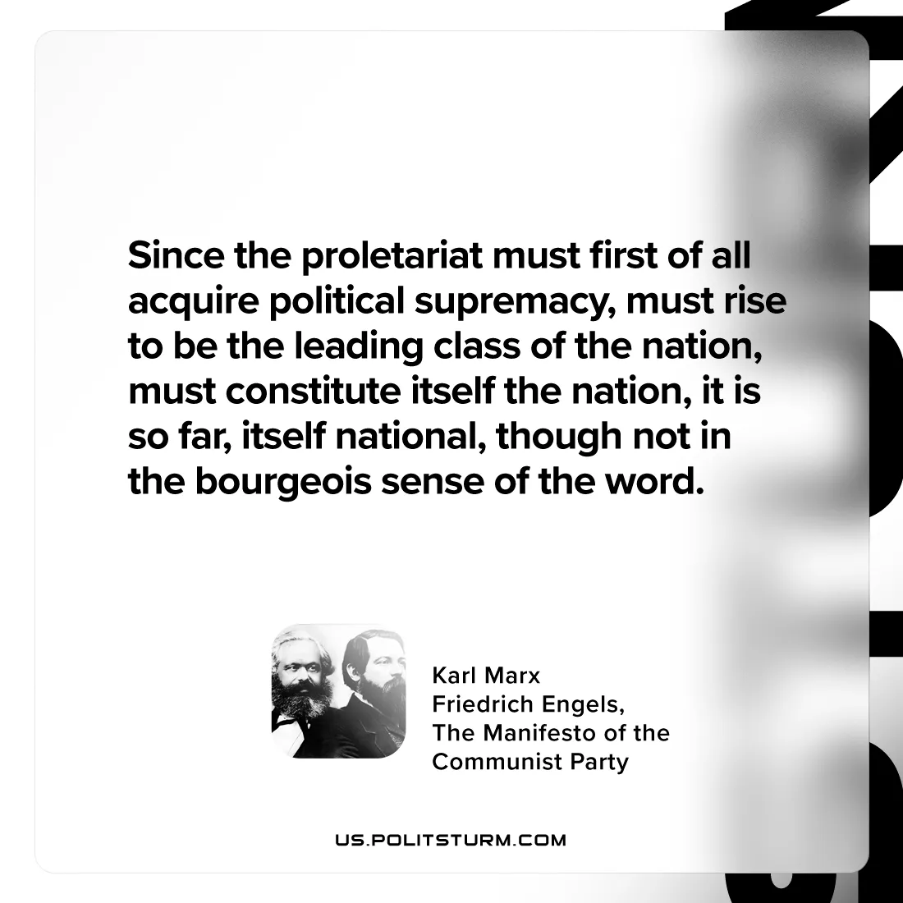

Original article
2024-07-13

"Since the proletariat must first of all acquire political supremacy, must rise to be the leading class of the nation, must constitute itself the nation, it is so far, itself national, though not in the bourgeois sense of the word.”
Karl Marx and Friedrich Engels, The Manifesto of the Communist Party

Original article

