Marx on the Revolutionary Dictatorship of the Proletariat
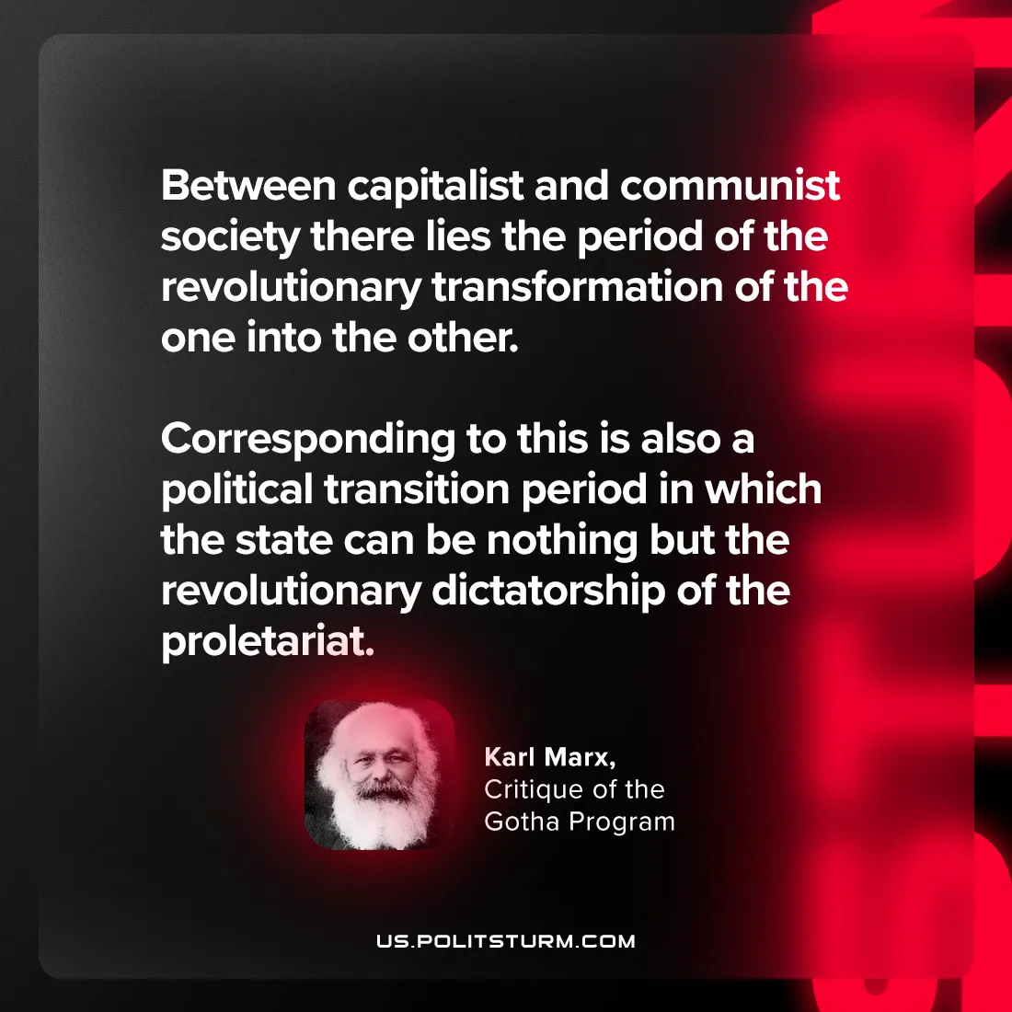

Original article
2024-09-07

“Between capitalist and communist society there lies the period of the revolutionary transformation of the one into the other. Corresponding to this is also a political transition period in which the state can be nothing but the revolutionary dictatorship of the proletariat.”
Karl Marx, Critique of the Gotha Program

Original article

