“M-L Pole” Avoids Confronting Cuba's Capitalist Restoration
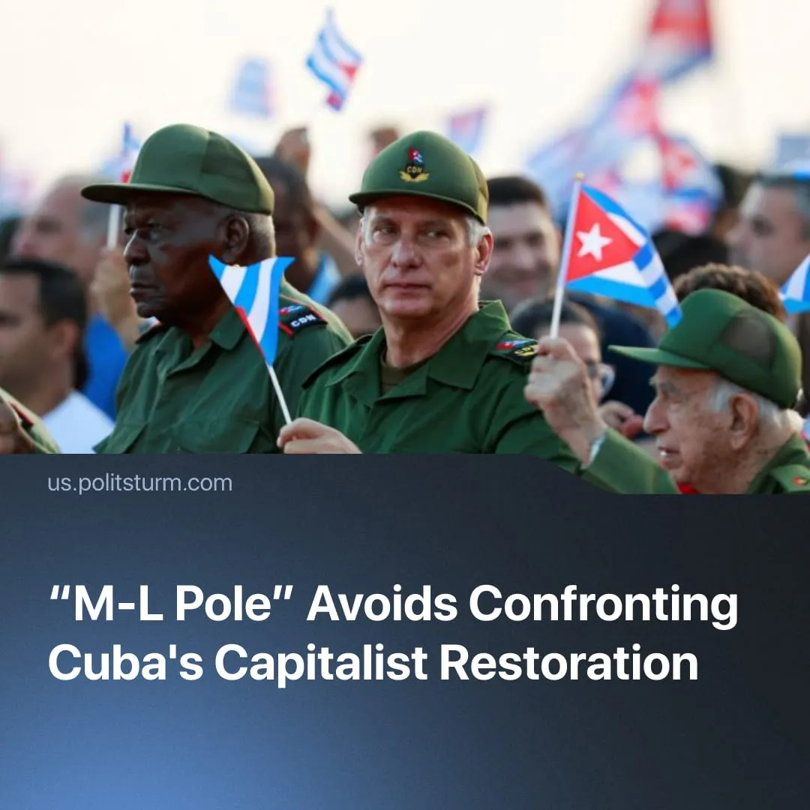

Original article
2026-08-08
2 min read

The “M-L Pole” is going to the conference in Havana with a position on Cuba that is almost indistinguishable from the position of the social chauvinists.
Details. On Friday, August 7, the 24th “International Meeting of Communist and Workers' Parties” begins in Havana. The meeting will take place against the backdrop of the "economic reforms" adopted in Cuba in mid-June, which finish the decade-long legalization of capitalism. According to Cuban President Díaz-Canel, these measures were originally planned for implementation in the early 2010s.
► Among the members of the “European Communist Action”, created by the KKE as a replacement for the failed “European Communist Initiative”, only the KKE and the SKP published separate materials on the capitalist “reforms” in Cuba.
► These materials portray the restoration of capitalism as a forced measure and a process that has only just begun. This assertion is refuted by facts and statements from Cuba's leadership. The SKP material is generally more critical and directly warns against supporting reforms under the pretext that they are being carried out by a formally communist organization. However, both organizations avoid characterizing the Cuban regime, the interests of which class it defends, and how communists should view the new bourgeoisie and the "Communist Party of Cuba", which consistently defends its interests against Cuban workers. The vagueness of the materials leaves room for ambiguous interpretations and suggests continued support for Cuba.
► Politsturm found no materials about Cuban “reforms” on the websites of other "ECA" organizations. However, many organizations, including the KKE, have published and continue to publish materials in support of the Cuban regime and hold "solidarity events".
► This position generally aligns with that of the social-chauvinists in Solidnet, who also chose to remain silent about the reforms and continued to defend Cuban opportunists. The social-chauvinist “Communist Party of Australia” published an editorial material named “Cuban reforms deserve support”.
What does this mean? The restoration of capitalism in Cuba has received a neutral-positive assessment from Solidnet organizations. This general convergence of positions can become a platform for false solidarity resolutions. Most likely, the "IMCWP" in Havana will be used as yet another demonstration of the false unity of the international communist movement.
► The previous "Meeting" in 2023 in Izmir was used in a similar manner. Back then, the organizers deliberately reduced the event to a focus almost exclusively on the Middle East, in order to silence the discussion of imperialism and the work of Solidnet, which had begun after the escalation in Ukraine.
► In turn, the “Communist Party of Cuba” may try to use this event to create the illusion of approval of the restoration of capitalism by international communists and to divert attention from the ongoing behind-the-scenes negotiations with the United States that are being conducted by the Cuban bourgeoisie and involve Raul Castro’s grandson.
Context. After the announcement of the "reforms" in Cuba, social chauvinists gave a positive assessment and presented them as a repetition of the "success" of China.
► One of the reasons for the "reforms" was to pave the way for American capital. As Politsturm previously wrote, this could be an attempt to replicate the Venezuelan scenario, in which Cuba would become dependent on the US in exchange for maintaining the political regime.

Original article

