Luxemburg on the Struggle Against Imperialism
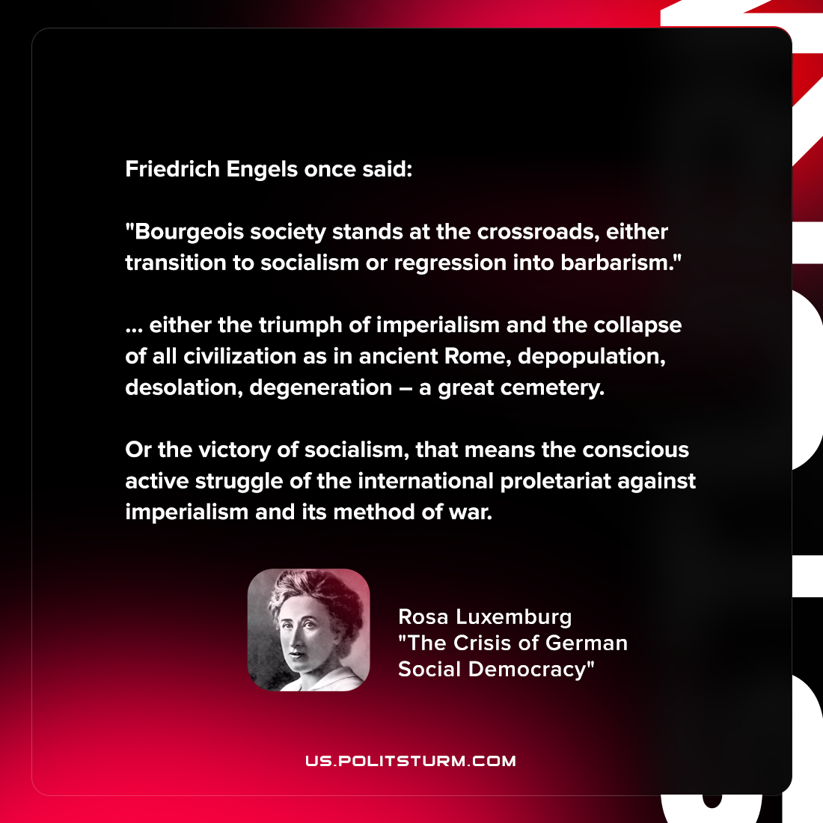

Original article
2022-04-20

Friedrich Engels once said: “Bourgeois society stands at the crossroads, either transition to socialism or regression into barbarism.”… either the triumph of imperialism and the collapse of all civilization as in ancient Rome, depopulation, desolation, degeneration – a great cemetery. Or the victory of socialism, that means the conscious active struggle of the international proletariat against imperialism and its method of war.

Rosa Luxemburg, “The Crisis of German Social Democracy”

Original article

