Low Wages Linked to Mortality, Excess Deaths in Middle-Aged Workers
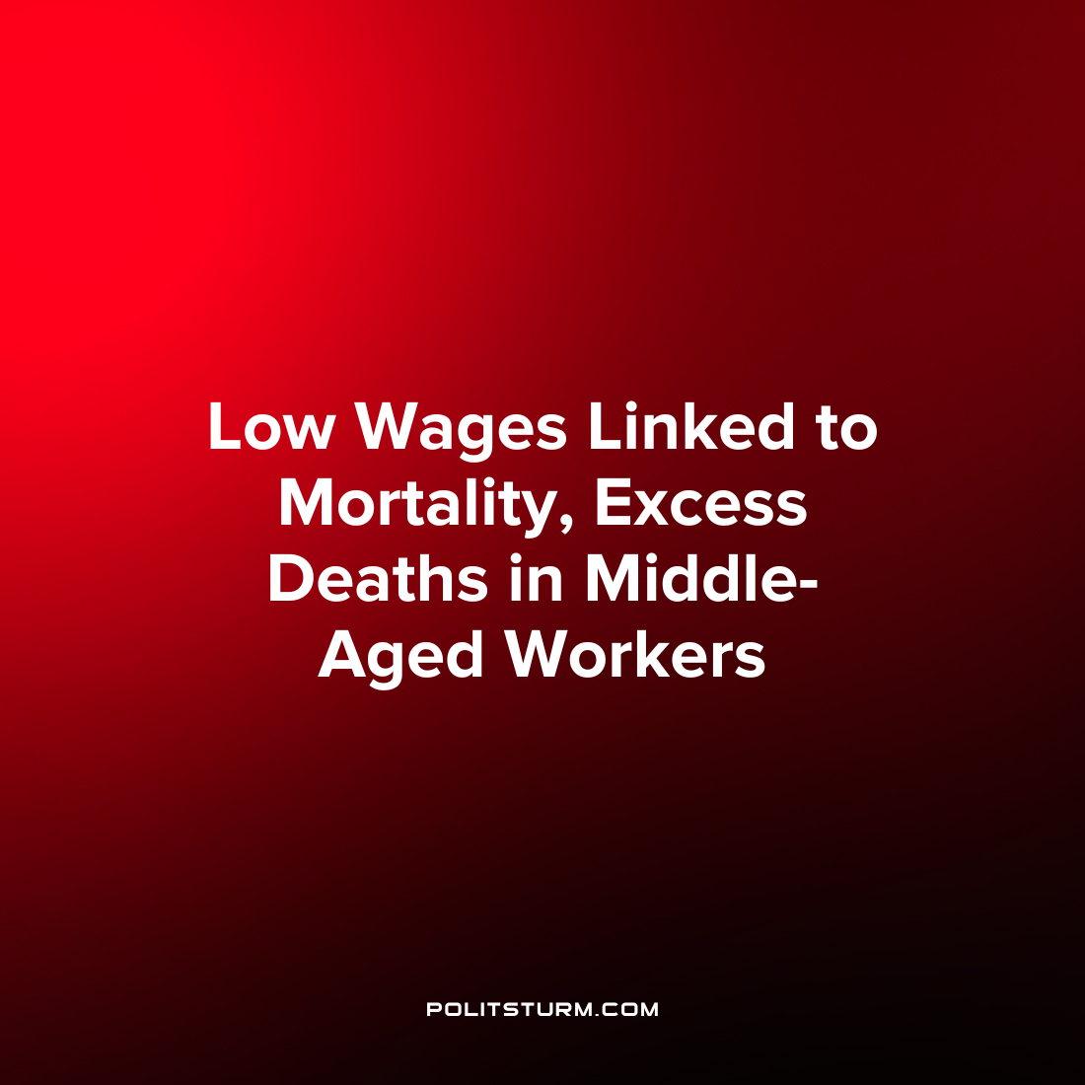

Original article
2023-02-27
1 min read

New research published in the JAMA Network sought to investigate whether earning low wages during the peak earning years for a worker was associated with excess mortality. The study tracked 4,002 workers who were ages 50 and older who reported earning hourly wages at three points during a 12-year period. Workers were characterized as low wage if they earned lower than the federal poverty line wages working full-time for the entire year.
Workers that experienced sustained periods of low wage earnings were associated with higher mortality rates and excess deaths. Workers were especially likely to face higher rates of mortality and excess deaths if they experienced periods of unstable employment.
The authors conclude that “our findings suggest that social and economic policies that improve the financial standing of the low-wage workers (eg. minimum wage laws) could improve mortality outcomes.”
However, under capitalism the owners of capital reap enormous profits from the labor of low-wage workers and the profit motive is paramount to the health and welfare of the workers. It is unsurprising to find that the lowest wage workers live shorter lives with increased stress and struggle. While the condition of the workers can improve within certain limits which are acceptable to the oligarchs, it is unrealistic to assume that this problem can be resolved under capitalism when the bourgeoisie continues to profit from this arrangement. It is imperative for the workers to study Marxism-Leninism and not rely on the political representatives of the bourgeoisie to improve their living conditions and struggle for their own class interests.
Source: 1

Original article

