London’s Water Supplier at Risk of Collapse
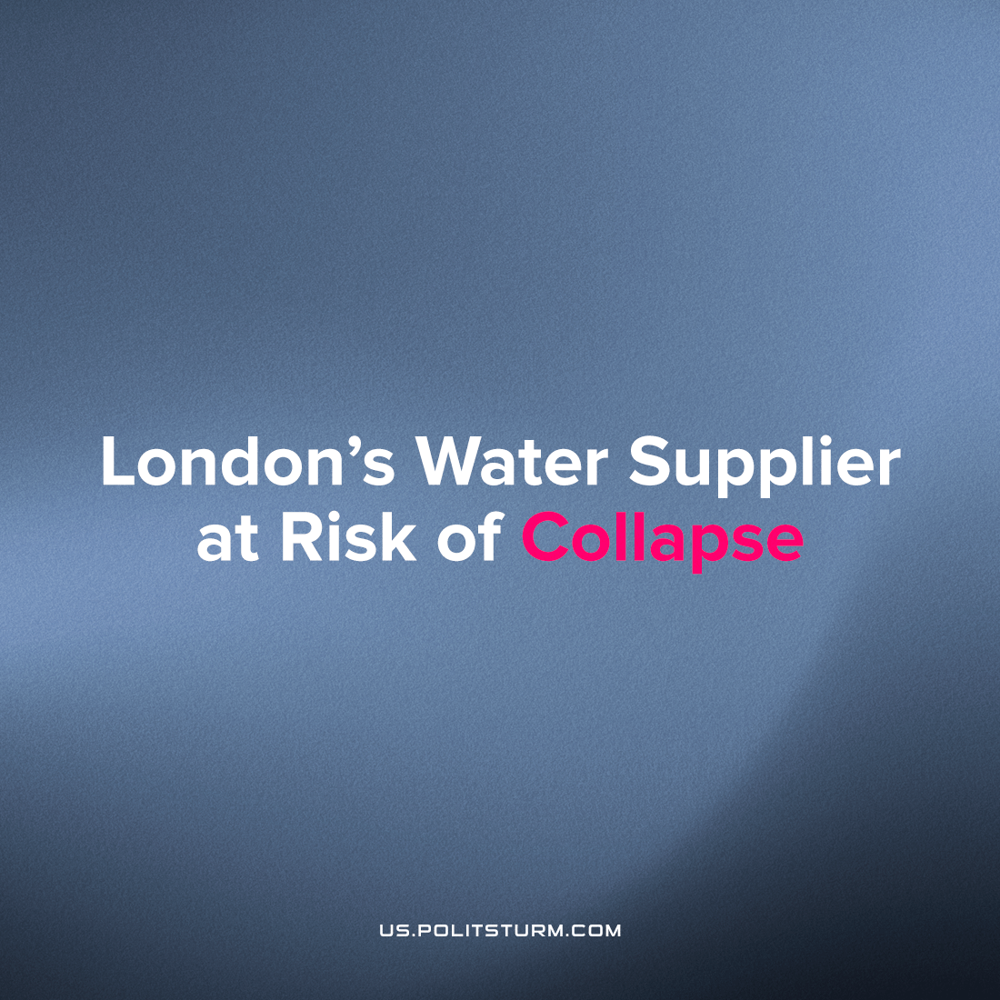

Original article
2023-07-12
3 min read

The United Kingdom is in a profound crisis; its economy dying a slow death, with social unrest and labour disputes increasing in size and scope while the political system enters paralysis. The latest stage of the crisis is in motion, threatening the working masses more and more directly.
Thames Water is one of the largest private water companies in Britain. It is responsible for the supply and treatment of most of London’s water supply as well as the water supply of neighbouring counties and cities; as such, the company holds a substantial local monopoly on water and millions of working Britons are dependent on the company for their basic water necessities.
On the 29th of June 2023, it was reported that Thames Water was holding urgent talks for emergency funding amid fears that it would soon collapse. The news was quickly picked up by the media because of the scale of the disaster that would befall the ordinary people of London and surrounding areas should such a scenario occur.
It was revealed that the company that supplies a quarter of the nation's population was ‘billions in debt’ despite charging their customers exorbitant rates. The company has been repeatedly criticised for discharging sewage into rivers and coastline and for its notoriously poor service that has led to leaks and even major flooding as they routinely syphon revenue to shareholders instead of upgrading London’s antiquated sewer and water network.
Such a collapse could lead to inadequately treated water being supplied to London area homes, potentially exposing millions to the cancer-causing pollution and sewage which has been identified in the country's water sources.
Even if a collapse were to be averted, taxpayers would be hit by higher costs from Thames Water as the ramshackled system continues to deteriorate after decades of neglect.
A recent poll has revealed that the majority of Britons, both Conservative and Labour voters, are substantially in favour of nationalising water and the rail networks and view the private ownership of these as a mistake and detrimental to British society. Whilst this is a positive development, it would be of little benefit to workers as Thames Water is financed and owes its debt due to pension schemes that are run and owned by the financial oligarchy: state ownership would merely be a change of management rather than a change in ownership.
In spite of this, the two major parties are committed to ensuring that private ownership shall never be infringed upon. This is true especially of the so-called “Labour” Party, which despite attempting to champion itself as the representative of the embattled working and middle-classes has rejected even the mildest social-democratic policies in an attempt to curry favour with the super-wealthy and prove himself to be an even more loyal stooge to the oligarchs and bankers than even PM Rishi Sunak: a former banker.
This positioning will not go unnoticed by the workers who are already rejecting the Labour Party; should “Sir” Keir Starmer succeed in moving in to 10 Downing Street, his staunchly pro-rich and anti-worker orientation will alienate the struggling Britons further and aggravate the social strife occurring in Britain, as they realise that no reform or mainstream party can end the misery, exploitation and deprivation that is inevitable under capitalism.
As time goes on, it is becoming increasingly clear the British imperialism is entering its death throes, the accumulation of a century of contradictions is starting to show and the capitalist-class will inevitably enter a fierce class-struggle amongst itself as billionaires vie to further centralise capital into their hands in addition to the escalation of the class-struggle between the proletariat and propertied classes that shall arise.
This is occurring at the moment with Thames Water, the company is a lucrative one, even if it is currently in a financial meltdown; should it be sold off, it would allow whichever company that gains the majority of Thames Water’s assets to essentially control the water supply of the plurality of English citizens; a huge boon to the billionaire’s already eye-watering profit margins.
With both main political parties giving the green light for such behaviour, British workers can expect higher fees and duties on basic necessities as the water becomes not only more expensive for households but for businesses- especially agriculture. With inflation driving the price of basic foodstuff to extraordinarily high levels, the prospect of yet further price increases will push British working families to the limit.
Source: 1, 2, 3

Original article

