Truss out: Sunak in — Britain's Political Chaos
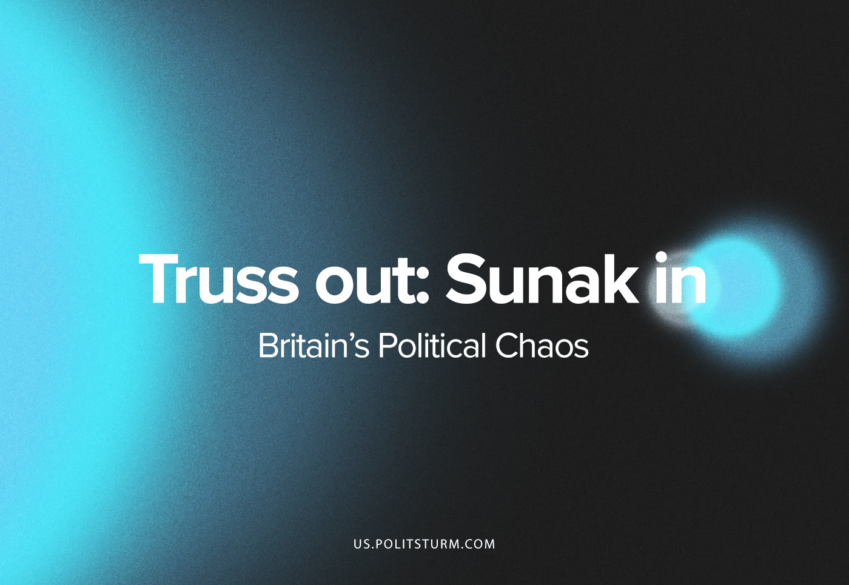

Original article
2022-10-26
11 min read

After just 44 days in office, Liz Truss’ tenure is over, but during her short administration as PM what Liz Truss has managed to accomplish has had an outsized role in undermining the already slim credibility of the political establishment. This extremely short chapter is the latest development in Britain’s growing crisis caused by capitalism’s internal laws. The behaviour and policies of the British politicians are merely reflections of their desperation to maintain the existing order of the bourgeoisie.
Liz Truss came to power following the resignation of Boris Johnson and his scandal-riddled administration. From the outset it was apparent that she would be completely ineffectual in restoring confidence in the ruling Conservative Party. The leadership contest revealed that her policies, influenced by right-wing think-tanks that sought to resurrect Thatcher’s economic policies, would solve none of the economic and social problems the UK currently faces, the sole purpose of her policies were to strengthen the capitalist class’ rule by driving the larger and larger sections of the British populace into deeper poverty.
This did not matter though to the Conservative Party members who voted for her for the appealing rhetoric towards their interests regardless of the wider effects on the country. Thus with just around 80,000 votes, Liz Truss became the Prime Minister of a country of 60 million people: 59,920,000 of whom did not and could not vote for her.
This, however, was sidelined quickly into her tenure; three days after asking Queen Elizabeth II to form a government with her as PM, the Queen passed away. Life in Britain was put on hold for a two-week spectacle of mourning. This inauspicious start was only confirmed after the monarch’s State Funeral was over.
The Government, upon its return to business on the 23rd of September, launched its notorious “mini-budget”: a set of tax cuts that scrapped plans to pay for public services by higher rates to cover the deficit caused by the COVID pandemic. The cuts were, according to then-Chancellor Kwarteng, ‘focused on growth.’ The measures were extraordinary, worth about £45 billion, and a complete volte-face from the policies of the immediately preceding administration.
These measures included:
- The basic rate of income tax would be reduced by one percentage point to 19% in April – one year earlier than planned.
- The unveiling of a cut to the top rate of income tax from 45% to 40%, meaning the UK will have a single higher rate from April.
- The threshold people in England and Northern Ireland would start paying for the stamp duty on home purchases would have risen to £250,000.
- For first-time buyers the threshold would have risen to £425,000 and the value of the property they can claim relief from would have increased from £500,000 to £625,000.
- Planned increases in the duty rates for beer, cider, wine and spirits would be axed
- The cap on bankers’ bonuses would be lifted.
- New investment zones, where business will benefit from tax cuts and planning rules will be relaxed to encourage house building, would have been established.
- Mr Kwarteng fulfilled his promises to reverse the rise in National Insurance payments introduced by Mr Johnson to pay for social care and tackle the NHS backlog.
- The confirmation that a planned corporation tax increase from 19% to 25% would also be scrapped.
It is clear that Truss’ cabinet was intent on driving the working-class of Britain into further misery in an attempt to maintain the propertied-class’ profit margins. This though, would be completely ineffectual. The failure of the government’s policies revealed just how deluded the imperialists in Britain had become.
This ‘mini-budget’ provoked intense backlash for appearing tone-deaf to the people’s outcries considering the government was proposing massive tax cuts for bankers while the cost-of-living crisis is threatening the very lives of Britain’s working-class with starvation and hypothermia in the coming winter. The mini-budget also rattled the bourgeoisie across the globe as the uncosted tax cuts relied on investors being willing to lend even more money to the UK in the midst of rampant inflation. According to Paul Johnson, director of the Institute for Fiscal Studies, an influential bourgeois think-tank: ‘The plan seems to be to borrow large sums at increasingly expensive rates, put government debt on an unsustainable rising path, and hope that we get better growth.’
The economic effects were immediate. As the Chancellor outlined the mini-budget to the House of Commons, the pound sank against the dollar to its lowest ever point. The situation grew worse with the revelation that the massive cuts were neither costed for by the Office for Budget Responsibility, nor was the Bank of England informed. As such, borrowing costs for the UK also increased as international financial groups were spooked at the course the British government had taken with Britain, being downgraded by Moody’s and S&P.
The former US Treasury secretary, Larry Summers went as far as to say ‘It makes me very sorry to say, but I think the UK is behaving a bit like an emerging market turning itself into a submerging market. Between Brexit, how far the Bank of England got behind the curve and now these fiscal policies, I think Britain will be remembered for having pursued the worst macroeconomic policies of any major country in a long time.’ As much as Truss desired to ensure that Britain’s monopolists maintained their position, her policies had the exact opposite effect. It now became more difficult for the British state to take loans and it became riskier for foreign capitalists to invest in the country: this made the mini-budget completely untenable.
The Prime Minister, desperate to cling on to power did not budge on the mini-budget announced by Mr. Kwarteng leading to increasing howls of indignation from the public, the opposition and from within their own party. In a desperate attempt to stymie a rebellion from their own backbenchers, Truss and Kwarteng were forced to U-turn on the proposed cut (from 45% to 40%) of the top rate of income tax on the 3rd of October.
They refused to reverse their stance on the mini-budget as a whole. The duo faced an issue though, the bourgeois class was growing increasingly alarmed at the economic and political crisis that was unfolding. Already suffering from rampant inflation, an increasingly stagnant economy and rising proletarian action in the form of strikes (strengthened by a labour shortage), sections of the bourgeoisie now risked losing substantially as the government’s economic plans (which to reiterate were implemented to increase the exploitation of the British proletariat and therefore maintain the bourgeoisie’s rate of profit) threatened to make borrowing and investment into British businesses more expensive.
Therefore the Prime Minister and the Chancellor were caught in an impossible position: in order not to appear weak and to appease their bourgeois financial backers and their petty-bourgeois voter base they could not reverse their plans to hollow out what remained of the British state. However, maintaining course would lead to an economic disaster which threatened the world market as a whole, alarming both the bourgeoisie of other nations as well as in Britain, thereby eroding what little support this government had: sticking to the programme meant certain catastrophe.
Seemingly paralysed in the face of these overwhelming contradictions the government desperately stuck to its guns in an attempt to ensure that the faction of the bourgeoisie that had supported them continued to support the current Tory clique. This ended up hastening their inevitable fate as the policies tore through the British economy which was already buckling from the effects of Brexit, the global pandemic and the aftershocks of the conflict in Ukraine. Most notably, the yield of gilts reached historic highs spiking by about 325% and 10-year gilts increasing to over 4%, a level not seen since the capitalist crisis of 2008.
This is significant. Gilts are a type of government bond specific to Britain issued by the Bank of England on behalf of His Majesty’s Treasury. They are seen as a “safe-haven” for foreign investors and are tightly linked with pension funds and insurance companies, and are therefore relied upon to ensure that the pensions of retirees are shielded from the effects of inflation and interest rates. The crisis threatened to affect a roughly £1.7 trillion slice of the UK’s pension sector ‘which dominates the market for long-term government debt’: in 2018, the value of private pension wealth as a whole was roughly £6.1 trillion meaning that nearly a third of all pensions would have been affected. This extraordinary rise in their yields led to panic selling and volatility in the market, threatening to destroy pensions and forcing the elderly into destitution.
Similarly, mortgage rates were pushed higher and higher with the government’s unwillingness to reverse their course. Considering that the total value of housing stock in Great Britain is estimated to be worth between £8.4tn to £9.2tn this represents a serious risk to Britain’s monopolists. With mortgage rates being driven higher coupled with the increasing costs of food and energy, there is a tangible possibility that significant sections of the UK risk losing their homes.
This reveals a fundamental trait of capitalism in the age of imperialism as outlined a century ago by Lenin: the bourgeoisie is not just waging a war against the working-class but also with each other as capital accumulates through this competition and centralises into fewer and fewer hands. The imperialists are at each other’s throats constantly in order to ensure their monopolies’ dominance within a national and global market.
The Bank of England was forced to intervene to ensure market stability and prevent a wider economic collapse. The damage, however, was done. Now that the PM had essentially risked wiping out the pensions of the elderly and ensured that her petty-bourgeois voter base would pay higher mortgage rates for years to come or perhaps even being proletarianised, she had alienated most of her bourgeois supporters.
Despite Kwarteng announcing that the official Budget would be announced on the 31st of October, instead of the 23rd of November, in an attempt to calm investors, nothing could be done whilst the government officially held its position. On the 14th of October, the Prime Minister’s closest ally, the Chancellor Kwasi Kwarteng, was sacked and replaced by the Tory grandee: Jeremy Hunt.
The selection of Jeremy Hunt was an attempt at reassuring the bourgeoisie that they needn’t worry and as proof of its good intentions announced a string of policy reversals: corporation tax rising to 25%, despite an earlier plan to freeze it at 19%, and an admission that public spending would have to grow less rapidly than previously planned, despite a pledge that there would be no return to austerity.
This, though, left the country with a £40 billion deficit that could not be relieved through borrowing; the cost of British state borrowing hit a 20-year high two days earlier. Three days later Jeremy Hunt announced that most of the mini-budget would be scrapped. This astonishing U-Turn ensured that Liz Truss would be gone in a matter of days not weeks. With the official budget being scheduled to be published in just a fortnight, it became clear that the current government had run out of options.
Conservative MPs were outraged and calling for the PM to quit, after consulting with senior members of her political party and then reneging on her promise to triple-lock pensions despite it being a manifesto pledge of the Conservative Party and backing it two weeks prior (once again further alienating her voter base) it became not a matter of if but when she would be removed as Prime Minister according to the senior Tory politician, Michael Gove.
On the 19th of October, she again flip-flopped and reiterated her pledge on preserving pensions despite reneging just a day before. Her Home Secretary, Suella Braverman published a scathing resignation letter after being forced to resign and that evening the House of Commons descended into mayhem: MPs allege that ministers physically pushed them into voting lobbies if they were wavering on whether to support the government while whips (those tasked with ensuring party discipline) shared ‘foul-mouthed’ exchanges during a vote on fracking.
On the 20th of October, Truss announced her resignation.
All of this occurred over the course of 44 days.
Liz Truss’ tenure is already the shortest in British political history. But what will cement its reputation further is the utter chaos it inflicted on British imperialism in just a few weeks. At a time where the working-class of Britain faces an onslaught against their living conditions, wages and health, the culmination of a decade of open class-warfare by the bourgeoisie, Liz Truss ensured that the only way the British monopolists can maintain their ranking on the global imperialist pyramid is through even more rapacious looting aimed against the workers. The next stage in the escalation of the attacks against the workers will lead to sharpening contradictions.
As previous reports by Politsturm have demonstrated, the United Kingdom has for years now been growing more unstable: economically, socially and politically. As a response to this the British proletariat has led a growing upsurge in strikes and the labour movement as a whole (trends consistent with the rest of Europe); the fact that even worse poverty faces workers in the country and now also threatens the petty-bourgeoisie (a class usually staunchly supportive of the Conservative Party) will lead to further unrest and the scope of the proletarian movement: something the bourgeoisie is acutely aware of.
The imperialists of Britain were organising themselves in the form of yet another leadership contest to decide on who shall be the third Prime Minister in just under two months to prepare for this. The front-runners in this latest contest were Rishi Sunak who was the Chancellor under Boris Johnson and (shockingly) Boris Johnson himself. Both required the backing of 100 MPs in order to be considered as in the running. On the evening of the 22nd of October it was reported that Sunak and Johnson had met and discussed the current situation.
Considering that the Conservative Party is fractured between those that despise Boris and those that consider Sunak to have betrayed him, such an unholy alliance must be seen as a move to unite the Party once more with Sunak likely becoming leader and PM and Boris Johnson becoming a senior cabinet minister akin to the Putin-Medvedev scheme of the 2000s where the two swapped offices to ensure that a change of administration had no impact on the trajectory of the Russian state. The talks, the details of which are currently unknown, came to nothing and on the morning of the 24th of October, Boris Johnson officially stated that he would not be entering the running for Prime Minister.
With the only other candidate, Penny Mordaunt, withdrawing from the contest minutes before the deadline for prospective politicians to put themselves in the race the 1922 Committee announced that Rishi Sunak, being the sole candidate left, would be the next leader of the Conservatives and the next Prime Minister three months after having lost to Liz Truss.
Rishi Sunak is a bourgeois politician par excellence. A graduate of Oxford and Stanford Universities, he would go on to work for Goldman Sachs between 2001 and 2004 before moving on to work at various hedge funds and marrying Akshata Murty, the daughter of an Indian billionaire and together they have an estimated combined wealth of £730 million. His rise to the “Great” Offices of State has been rather remarkable. Before entering government he was a rather obscure MP, no doubt his meteoric rise was aided by his mega-wealthy friends and family.
Despite his popularity among the British public who associate him with economic policies that supported them during the COVID-19 pandemic it is highly doubtful that his popularity can endure the deepening of the crisis that face Britain. His selection as leader of the Tories is primarily an attempt at uniting the extremely fractured Conservative Party (a fact admitted by Rishi in his first public speech since becoming the incoming PM). Given the nature of the current crisis that faces British capitalism, Sunak’s tenure will undoubtedly face the same problems that previous administrations faced and as a former banker himself his priority, without a doubt, will be to stifle social dissent and maintain the revenues of the capitalists that are directing him. He can only do this by immiserating and exploiting the already poverty-stricken masses. How successful he shall be in this endeavour remains to be seen.
What is abundantly clear is that whatever British government replaces the current one, there is no escape from the worsening crisis for the working-class. Boris Johnson, Rishi Sunak and Liz Truss have all demonstrated at every opportunity their utter contempt for the workers of Britain. No matter who holds the reins of power, extraordinary cuts to public spending will follow as the UK’s ramshackled infrastructure, hospitals and schools will buckle under this increasing pressure. The economy will continue to stagnate during this period and inflation will continue to rise. British workers will go hungry and freeze in their homes. The capitalist class can offer no solution, even a Labour government would be forced to implement cuts as their social democratic policies cannot overcome the scale of this crisis. The only hope the workers have is to depose the rule of capital.
There is still a light of hope. Trade unions this year have been increasing their militancy and pledge to fight for better wages and working conditions should no attempts be made to shield the workers from the ongoing crisis. But there are also enormous hurdles to overcome before the proletariat can begin to aspire to overthrow capitalism.
There is no dedicated vanguard party to organise the workers towards their power: the “Communist” Party of Britain is shamefully ignoring the revolutionary purpose a communist party should have and encouraging tailism and “political unity” with the imperialist Labour Party in a supposed “anti-monopoly” league which can hypothetically, then, vote away capitalism: an utterly ludicrous and impossible proposal. This opportunist group proposes such a course instead of working to agitate the workers and trade unions towards the end of the dictatorship of the bourgeoisie and the successful institution of a dictatorship of the proletariat.
If hunger, disease, poverty and illiteracy are to be overcome, dedicated communists in Britain must unite and form a true vanguard party without delay to organise the workers because it is only the workers who can end capitalism and its consequences. There is no other option.

Original article

