Liz Truss Elected as New British PM
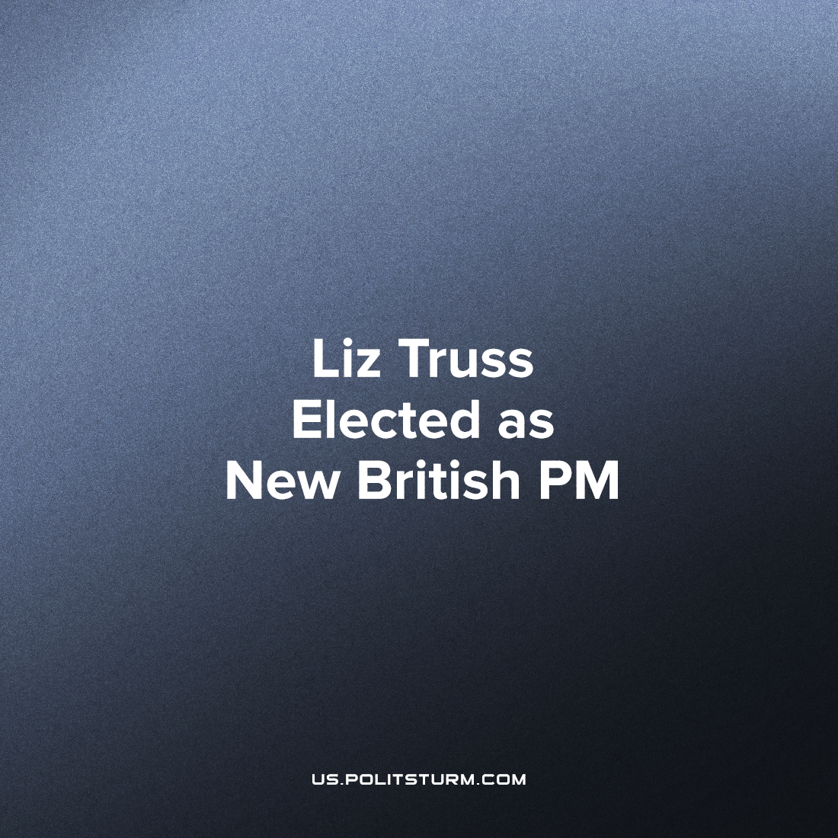

Original article
2022-09-12
2 min read

Liz Truss has defeated Rishi Sunak in the ruling conservative party leadership election and is now the new British Prime Minister, having received 81,326 votes compared to Sunak’s 60,399. The ghost of Margaret Thatcher haunts this leadership contest with both candidates having named her as their party’s greatest historical leader. With Truss styling herself after the “Iron lady” and Sunak who had described his economic platform as “common sense Thatcherism”.
Margaret Thatcher’s term in power was characterised by privatisations, tax cuts for the wealthy (and tax increases for the poor – like the poll tax), mass unemployment, the growth of finance capital, the destruction of British industry and the repression of trade unions and striking workers. The day of her death was met with impromptu street parties across Britain, with the song “Ding Dong! The Witch is Dead” reaching number two on the music charts shortly after – Thatcher is hated by the majority of the British working class.
So why were the two candidates competing to be viewed as her torchbearer? Firstly, this election is not decided by the public as a whole, only the conservative party members – who view Margaret Thatcher as an icon. Secondly, with inflation now past 10% and still rising as well as a resurgent worker’s movement, the situation in Britain somewhat resembles that when Thatcher first rose to power. Liz Truss has, following in the footsteps of Thatcher, has said “We need tough and decisive action to limit trade unions’ ability to paralyse our economy. I will do everything in my power to make sure that militant action from trade unions can no longer cripple the vital services that hard-working people rely on”. She has promised to crack down on the democratic right to strike by making the laws on balloting more restrictive (they already the most restrictive in Western Europe), increasing the minimum time between a ballot and the strike (allowing for more time to employ strike-breakers) and making unions of key industries guarantee a minimum level of service. These promises, if carried through, in the words of the RMT trade union leader Mick Lynch, “amount to the biggest attack on trade union and civil rights since labour unions were legalised in 1871”. He continues, “If these proposals become law, there will be the biggest resistance mounted by the entire trade union movement, rivalling the general strike of 1926, the Suffragettes and Chartism”.
No matter who wins in bourgeois democracy, it is working people who lose, for liberal democracy is just a façade for the dictatorship of capital. And they will continue to sacrifice democratic rights and people’s livelihoods in defence of capitalism. Liz Truss’s proposed anti-trade union laws must be wholeheartedly opposed as they clamp down on one of the most effective method for the workers to defend their class’s interests against the capitalists.
Sources: 1, 2

Original article

