Liebknecht on Capitalist Education
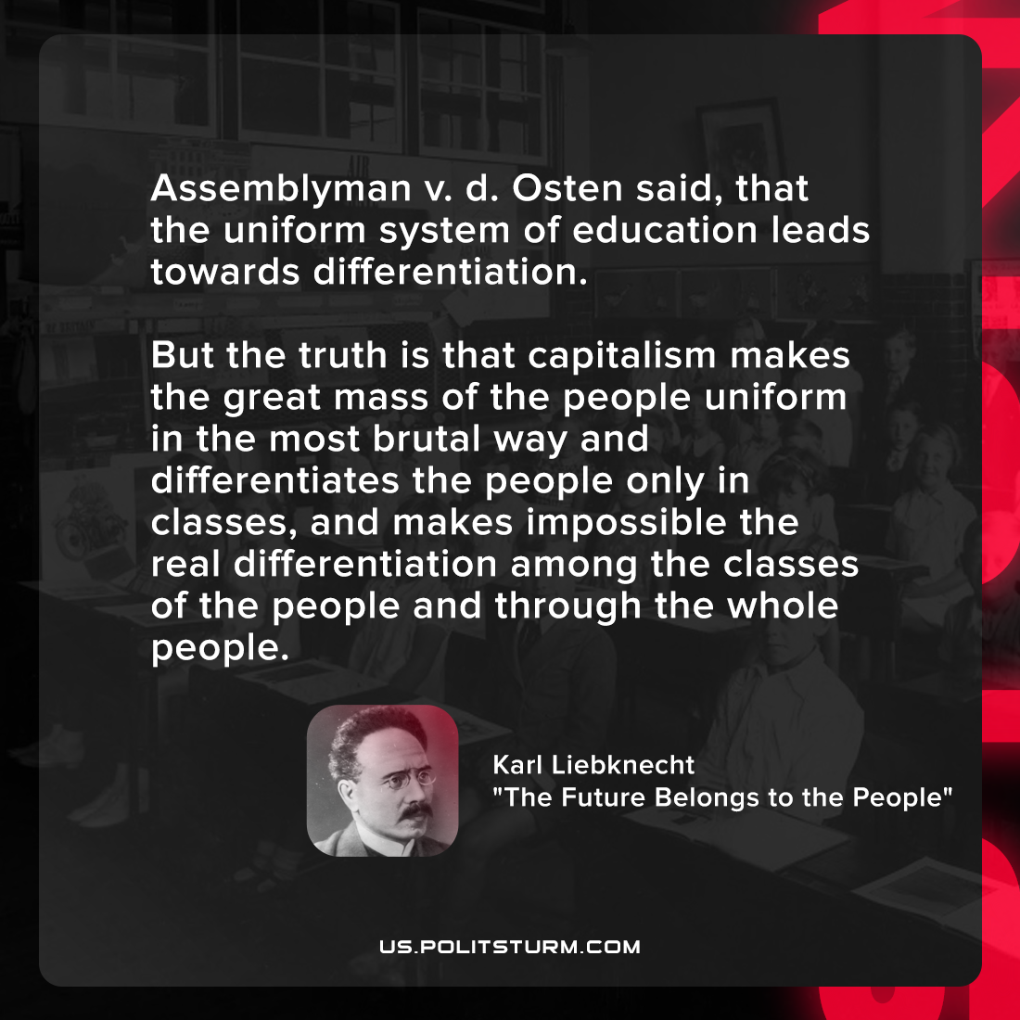

Original article
2022-04-24

Assemblyman v. d. Osten said, that the uniform system of education leads towards differentiation. But the truth is that capitalism makes the great mass of the people uniform in the most brutal way and differentiates the people only in classes, and makes impossible the real differentiation among the classes of the people and through the whole people.

Karl Liebknecht, “The Future Belongs to the People”

Original article

