Lenin on Methods of Struggle
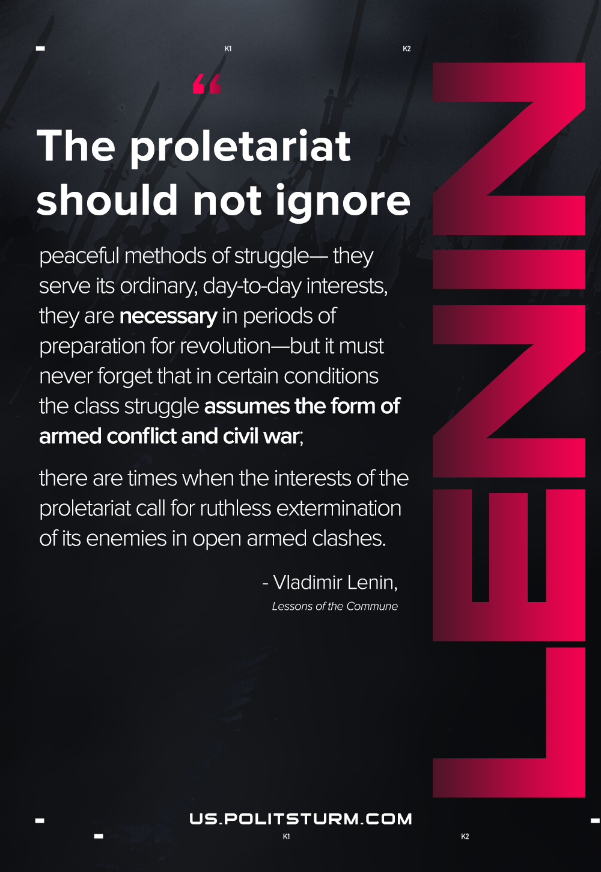

Original article
2021-02-07

The proletariat should not ignore peaceful methods of struggle—they serve its ordinary, day-to-day interests, they are necessary in periods of preparation for revolution—but it must never forget that in certain conditions the class struggle assumes the form of armed conflict and civil war; there are times when the interests of the proletariat call for ruthless extermination of its enemies in open armed clashes.

Vladimir Lenin, Lessons of the Commune

Original article

