Lenin to Emancipate Humanity
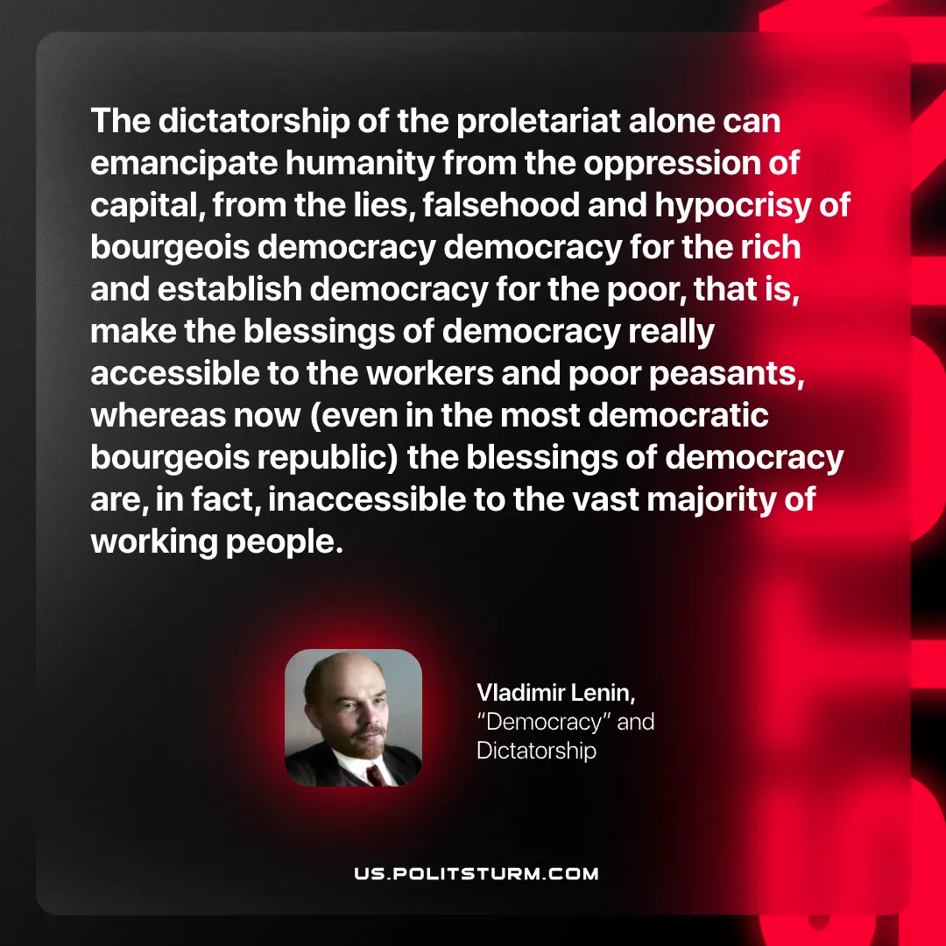

Original article
2026-10-01

The dictatorship of the proletariat alone can emancipate humanity from the oppression of capital, from the lies, falsehood and hypocrisy of bourgeois democracy democracy for the rich and establish democracy for the poor, that is, make the blessings of democracy really accessible to the workers and poor peasants, whereas now (even in the most democratic bourgeois republic) the blessings of democracy are, in fact, inaccessible to the vast majority of working people.
Vladimir Lenin, "Democracy" and Dictatorship

Original article

