Lenin to Attain Political Education
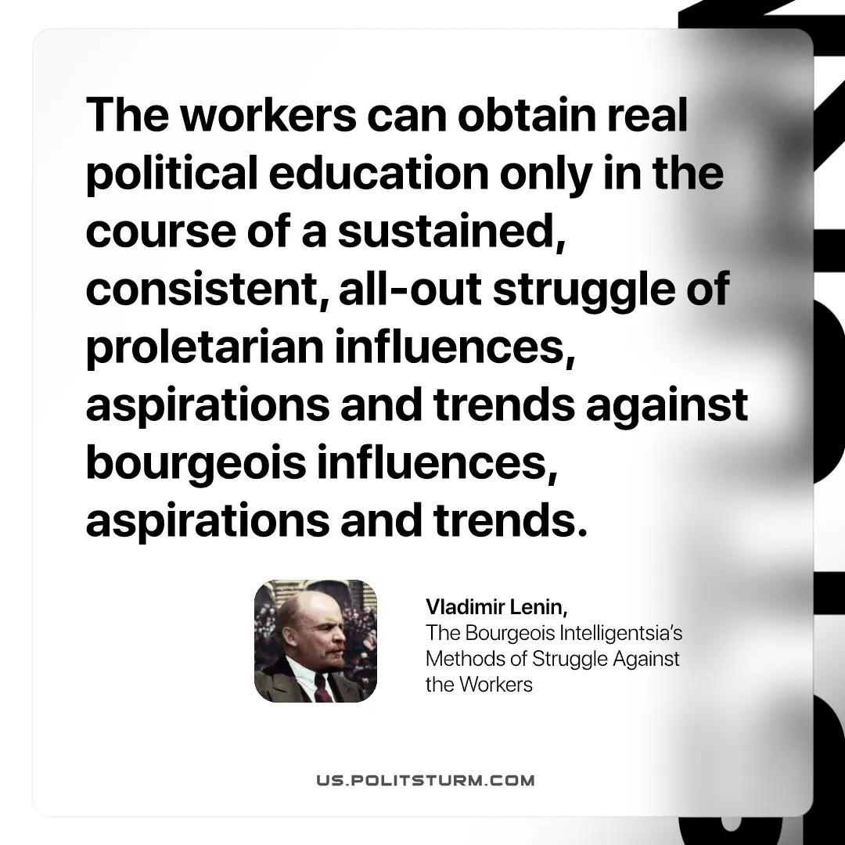

Original article
2026-10-04

The workers can obtain real political education only in the course of a sustained, consistent, all-out struggle of proletarian influences, aspirations and trends against bourgeois influences, aspirations and trends.
Vladimir Lenin, The Bourgeois Intelligentsia's Methods of Struggle Against the Workers

Original article

