Lenin on World Revolution
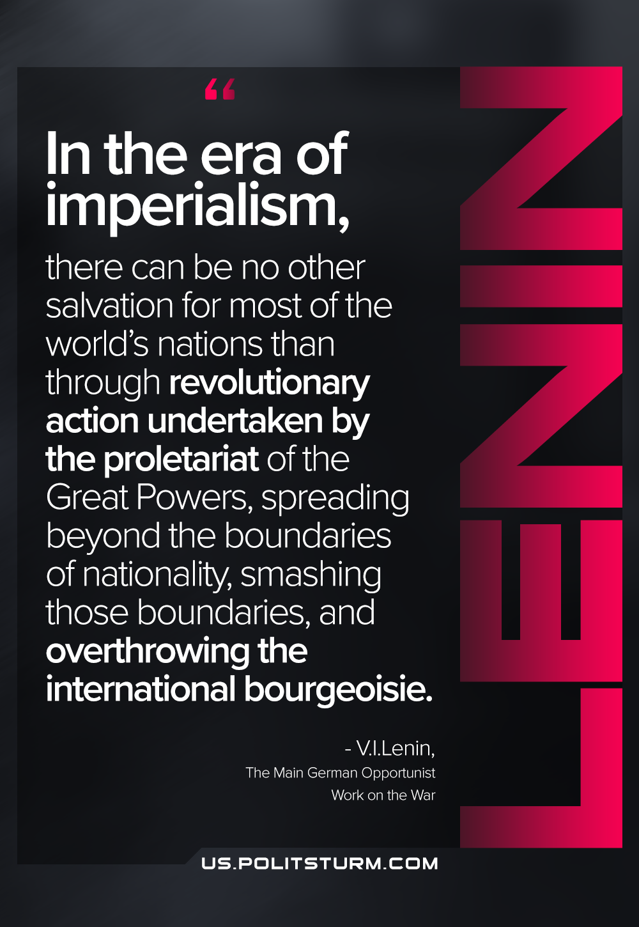

Original article
2021-04-01

In the era of imperialism, there can be no other salvation for most of the world’s nations than through revolutionary action undertaken by the proletariat of the Great Powers, spreading beyond the boundaries of nationality, smashing those boundaries, and overthrowing the international bourgeoisie.
The Main German Opportunist Work on the War

Original article

