Lenin on Workers
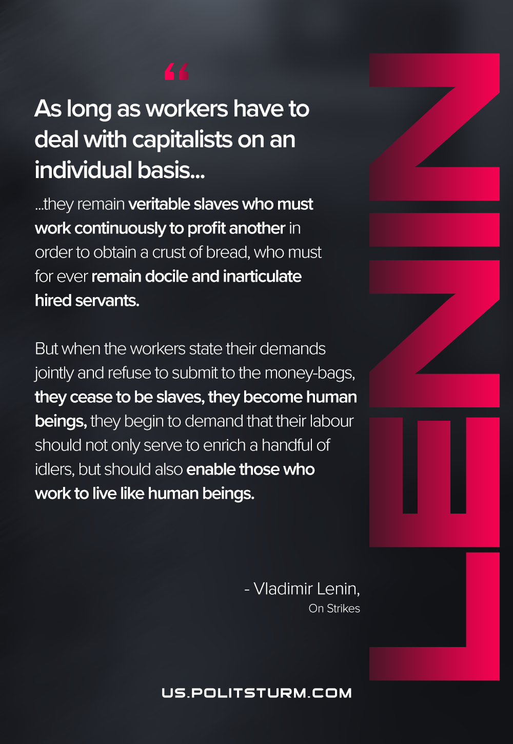

Original article
2021-02-27
1 min read

As long as workers have to deal with capitalists on an individual basis they remain veritable slaves who must work continuously to profit another in order to obtain a crust of bread, who must for ever remain docile and inarticulate hired servants. But when the workers state their demands jointly and refuse to submit to the money-bags, they cease to be slaves, they become human beings, they begin to demand that their labour should not only serve to enrich a handful of idlers, but should also enable those who work to live like human beings.
Lenin, On strikes

Original article

