Lenin on Winning Unity in the Labor Movement
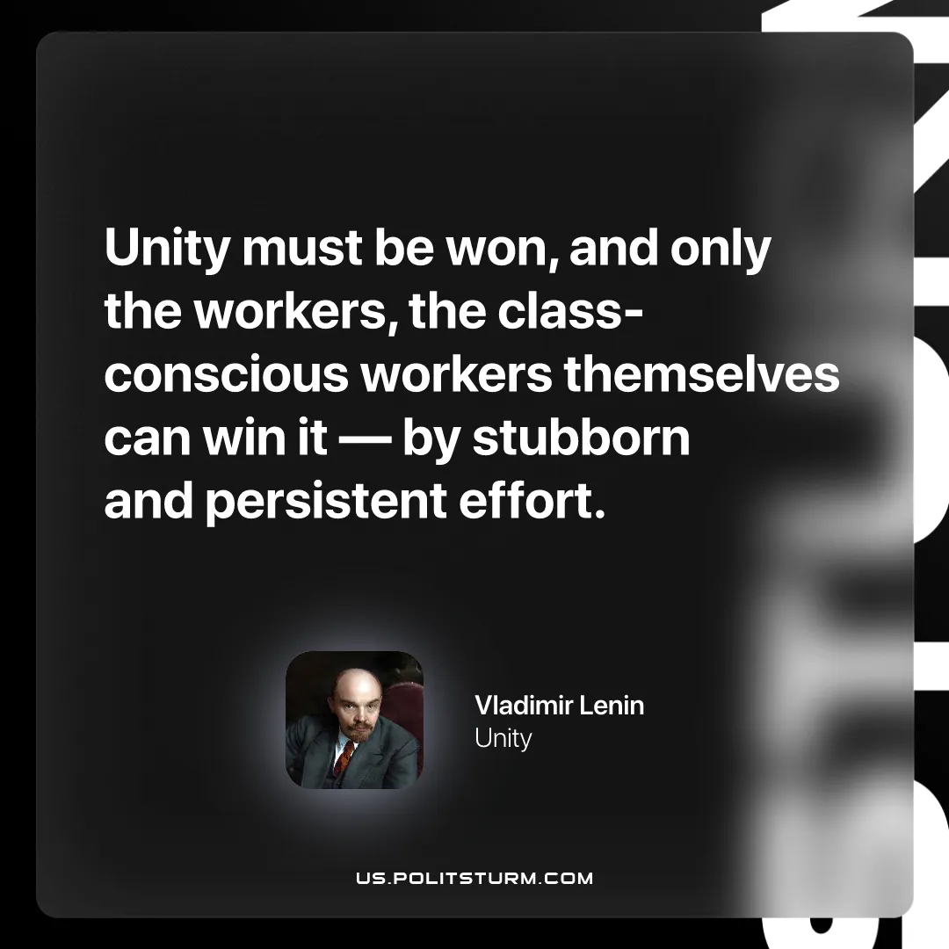

Original article
2026-04-23

“Unity must be won, and only the workers, the class-conscious workers themselves can win it – by stubborn and persistent effort.”
Vladimir Lenin, Unity

Original article

