Lenin on Who are Social‑Chauvinists
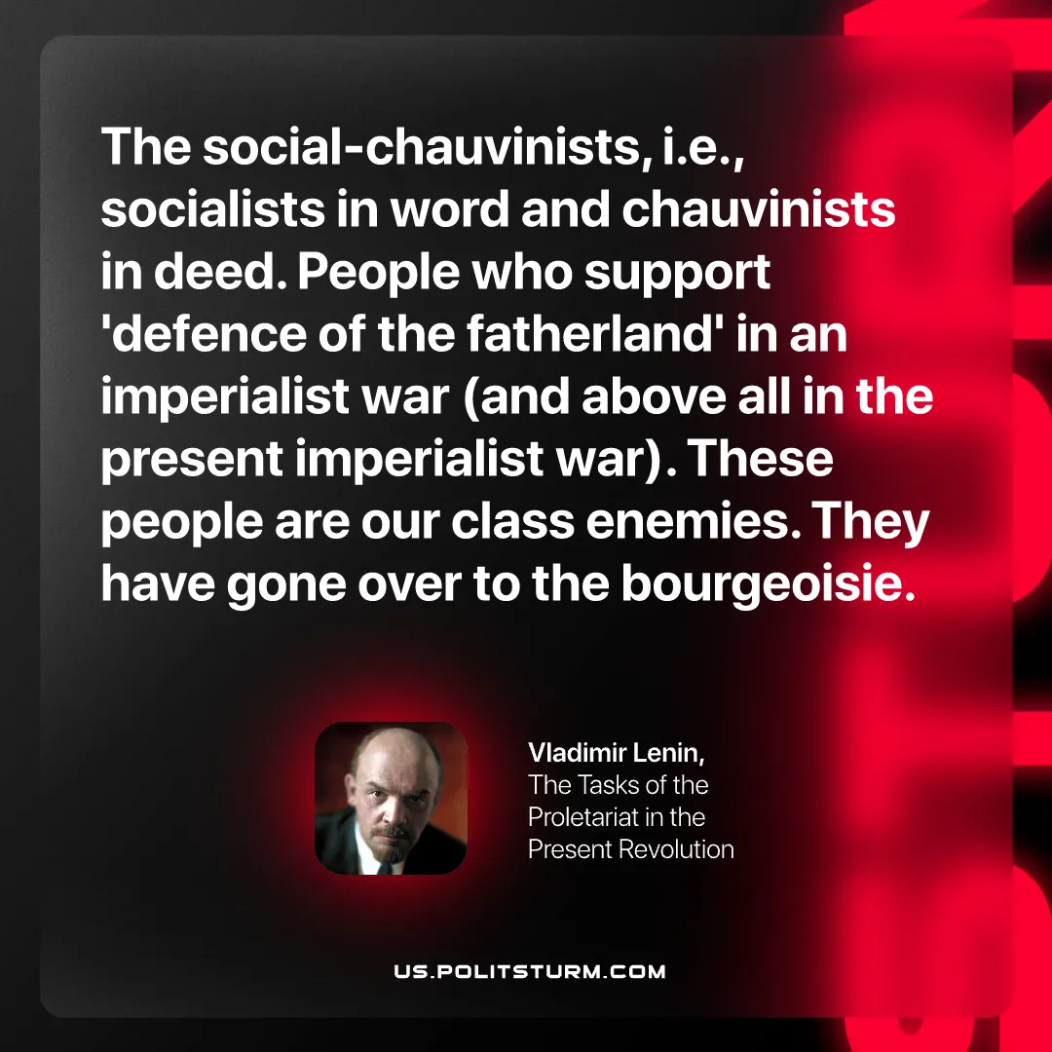

Original article
2026-06-09

The social‑chauvinists, i.e., socialists in word and chauvinists in deed. People who support 'defence of the fatherland' in an imperialist war (and above all in the present imperialist war). These people are our class enemies. They have gone over to the bourgeoisie.
Vladimir Lenin, The Tasks of the Proletariat in the Present Revolution

Original article

