Lenin on What Unites the Proletariat
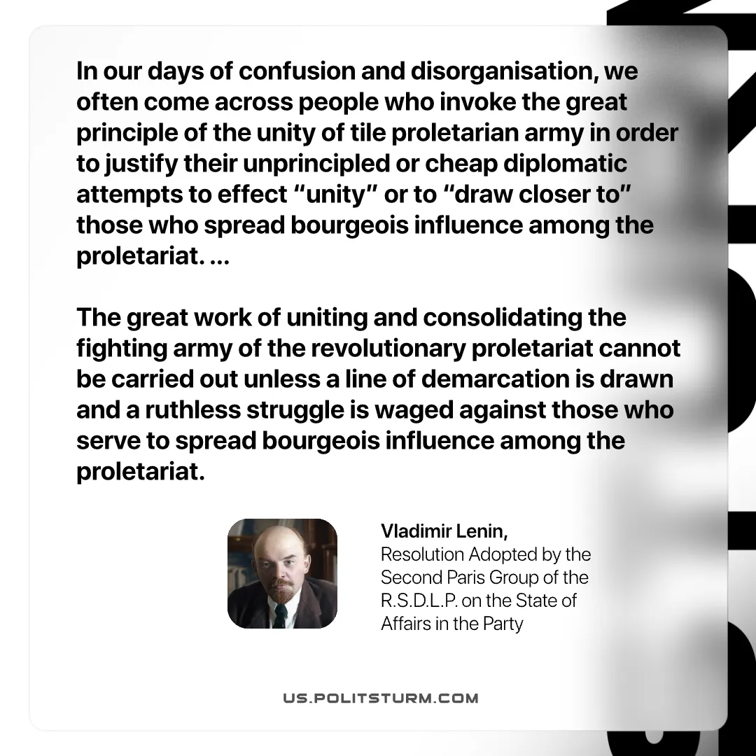

Original article
2026-07-30
1 min read

In our days of confusion and disorganisation, we often come across people who invoke the great principle of the unity of tile proletarian army in order to justify their unprincipled or cheap diplomatic attempts to effect "unity" or to "draw closer to" those who spread bourgeois influence among the proletariat. ...
The great work of uniting and consolidating the fighting army of the revolutionary proletariat cannot be carried out unless a line of demarcation is drawn and a ruthless struggle is waged against those who serve to spread bourgeois influence among the proletariat.
Vladimir Lenin, Resolution Adopted by the Second Paris Group of the R.S.D.L.P. on the State of Affairs in the Party

Original article

