Lenin on What Makes a Real Internationalist
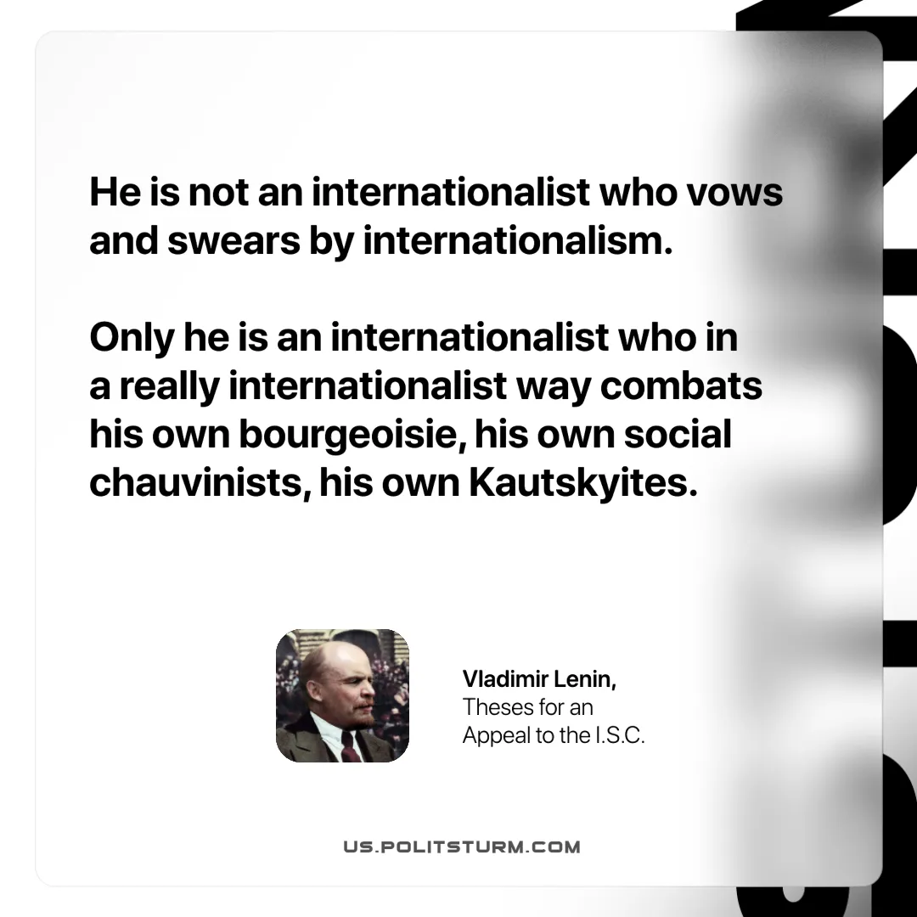

Original article
2025-07-26

“He is not an internationalist who vows and swears by internationalism. Only he is an internationalist who in a really internationalist way combats his own bourgeoisie, his own social-chauvinists, his own Kautskyites.”
Vladimir Lenin, Theses for an Appeal to the I.S.C.

Original article

