Lenin on What Discipline Means in the Context of the Party
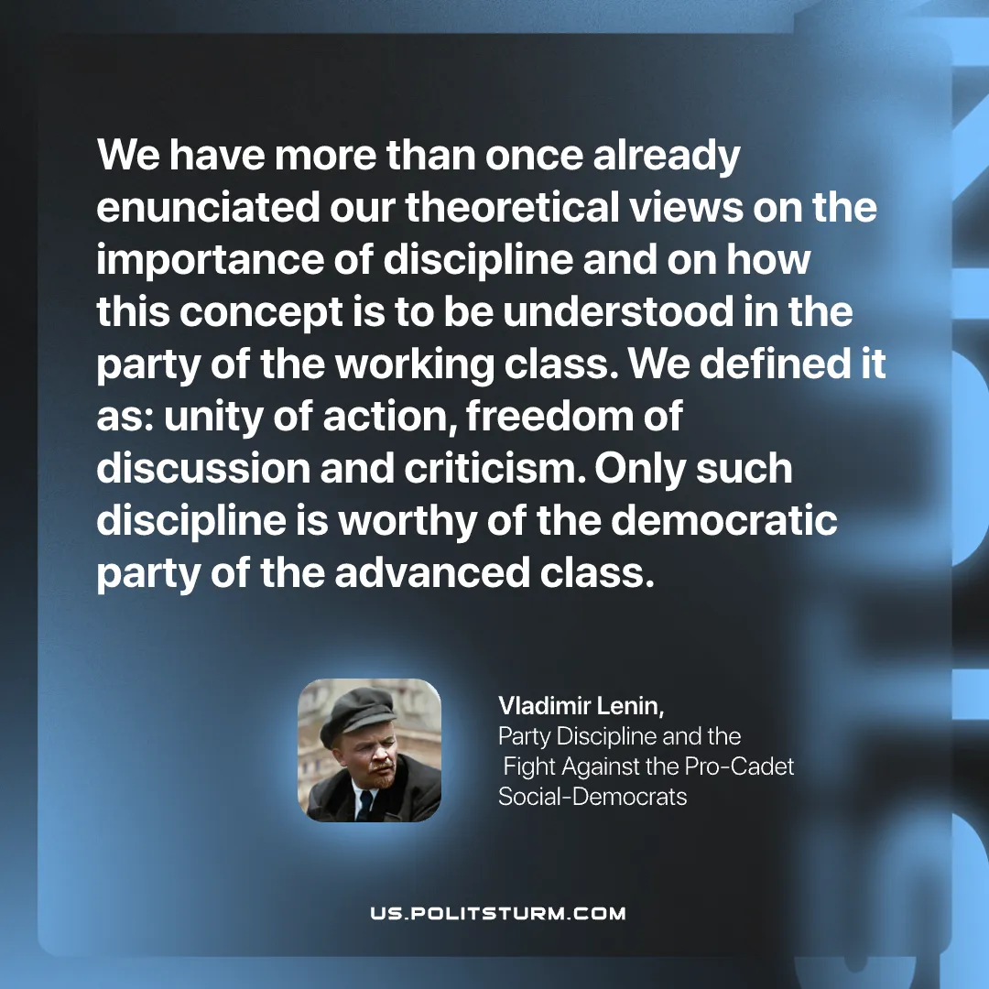

Original article
2025-12-27

“We have more than once already enunciated our theoretical views on the importance of discipline and on how this concept is to be understood in the party of the working class. We defined it as: unity of action, freedom of discussion and criticism. Only such discipline is worthy of the democratic party of the advanced class.”
Vladimir Lenin, Party Discipline and the Fight Against the Pro-Cadet Social-Democrats

Original article

