Lenin on Wars Two Outcomes
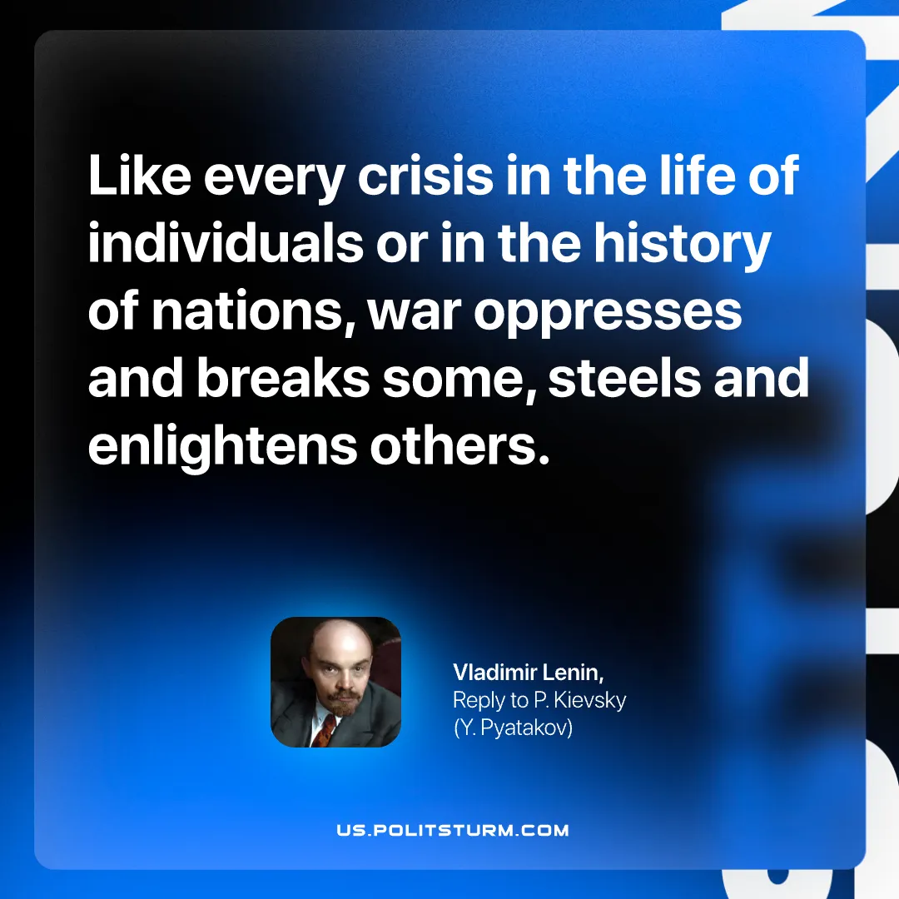

Original article
2026-10-27

Like every crisis in the life of individuals or in the history of nations, war oppresses and breaks some, steels and enlightens others.
Vladimir Lenin, Reply to P. Kievsky (Y. Pyatakov)

Original article

