Lenin on Wars
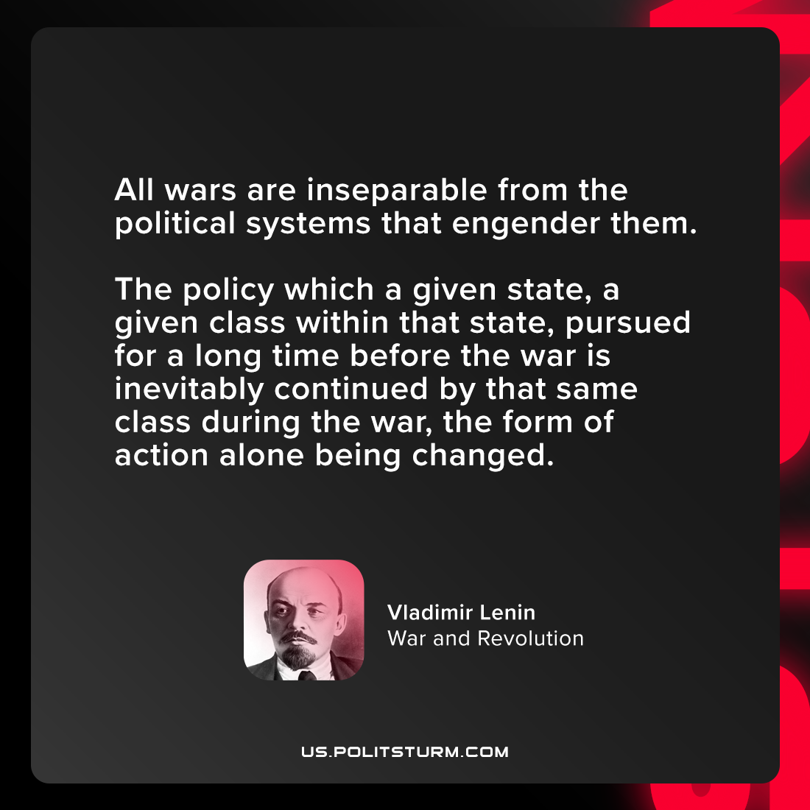

Original article
2021-08-01

All wars are inseparable from the political systems that engender them. The policy which a given state, a given class within that state, pursued for a long time before the war is inevitably continued by that same class during the war, the form of action alone being changed.

Vladimir Lenin, “War and Revolution”

Original article

