Lenin on War
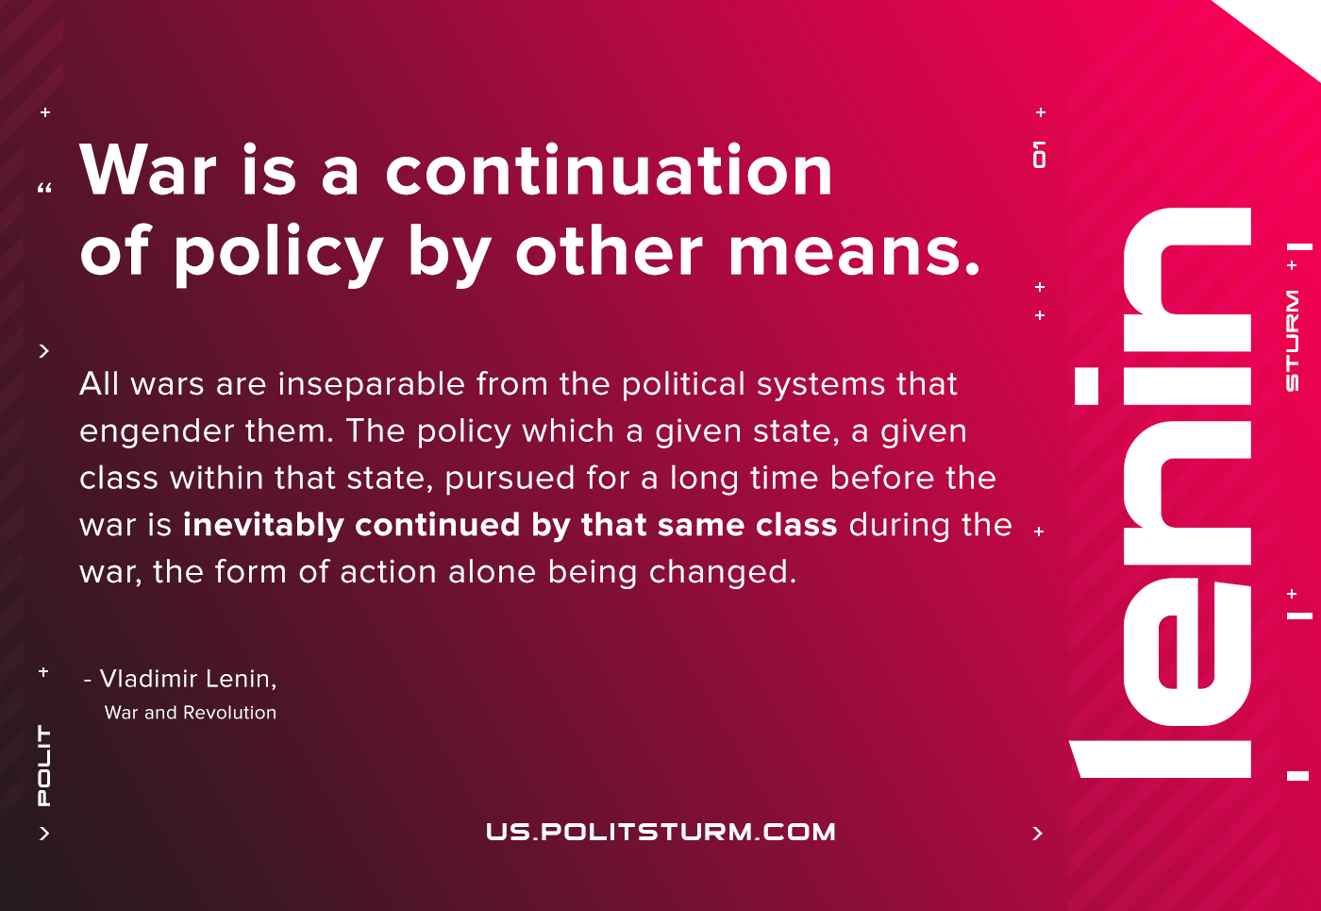

Original article
2021-01-13

War is a continuation of policy by other means. All wars are inseparable from the political systems that engender them. The policy which a given state, a given class within that state, pursued for a long time before the war is inevitably continued by that same class during the war, the form of action alone being changed.
Vladimir Lenin, “War and Revolution”

Original article

