Lenin on War and Profit
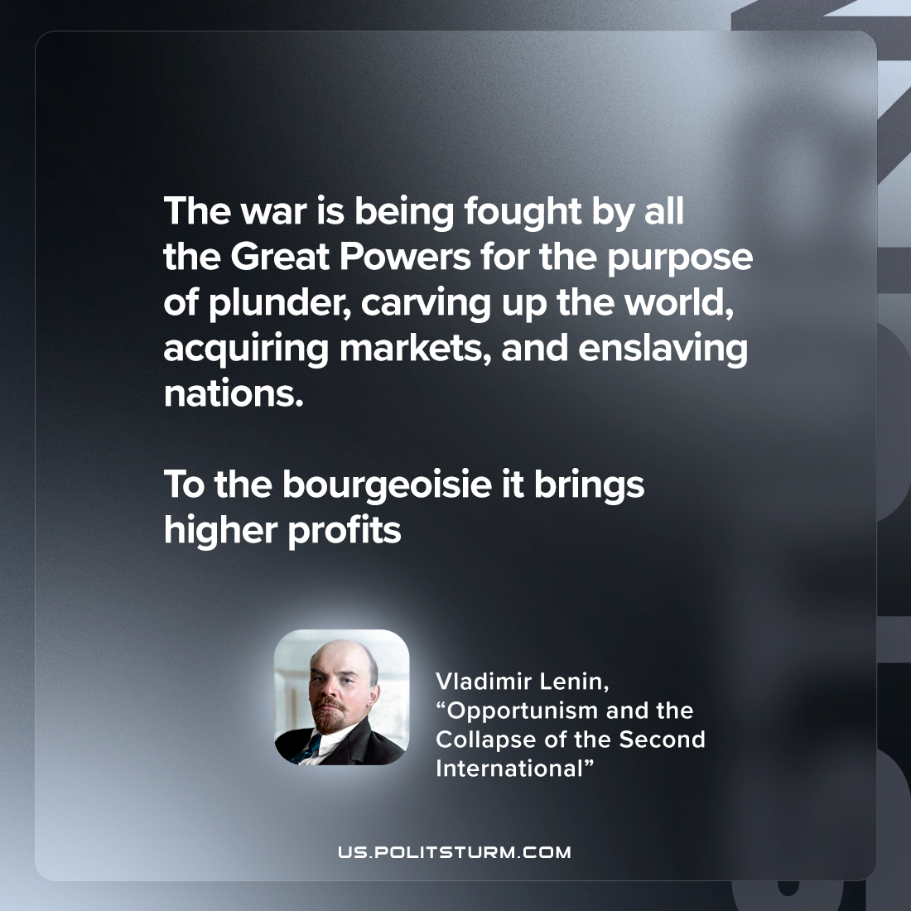

Original article
2023-01-19

"The war is being fought by all the Great Powers for the purpose of plunder, carving up the world, acquiring markets, and enslaving nations. To the bourgeoisie it brings higher profits"
Vladimir Lenin, “Opportunism, and the Collapse of the Second International”

Original article

